Design PowerPoint Templates for Accessibility Workbook

Version 04 – September 2023

[](https://oalmsps.od.nih.gov/DDO/CDMP/508/Accessible%20Design%20Training/Catalog-AccessibleTemplateDesigns.pptx)

Significantly reduce or eliminate the Check Reading Order errors in PowerPoint. Comply with several U.S. Department of Health and Human Services - HHS Accessibility Conformance Checklist criteria, Web Content Accessibility Guidelines - WCAG, Microsoft Accessibility Checker Inspection Results, and Section 508 requirements.

The document accompanies the Design PowerPoint Templates for Accessibility training program. An accessible template will give Authors (document creators) a head start. It will not address every accessibility issue.

**National Institutes of Health** ([NIH](https://www.nih.gov/))

Office of Acquisitions and Logistics Management ([OALM](https://oalm.od.nih.gov/))

Contract Data Management Program ([**CDMP**](https://oalm.od.nih.gov/ddo))

[Logo CDMP SharePoint & Yammer - Click link to visit sites.](https://oalmsps.od.nih.gov/DDO/CDMP/Directory/SitePages/Home.aspx)

# About this Program

Version 01 – September 2023

This program aims to provide users with a head start to accessibility.

By the end of the course, students will be familiar with the PowerPoint Slide Master view, the slide layout, placeholders, and the many benefits of using them. Students will also understand the 508 requirements and how to use and resolve issues found in the accessibility checker. In addition, common HHS Accessibility Conformance Checklist items that the accessibility checker cannot detect are addressed. Feel free to create a different template or to use the placeholders, layouts, and color combinations that best fit your presentation needs.

**Note:** Not all accessibility issues can be addressed with a template.

## Responsibilities

**Author**

The Author is the person responsible for creating the presentation. They work in Normal view. The Author selects slide layouts that fit their presentation needs.

The Author is responsible for ensuring the presentation passes the Microsoft Accessibility Check Inspection Results and any applicable 508 requirements.

**Template Designer**

The Template Designer designs slide layouts with universal accessibility features. The Template Designer works in Slide Master view.

Distribute templates to users and provide training as needed.

## Supplemental Documents

This document accompanies the **Design PowerPoint Templates for Accessibility (.pptx)** training program. Additional supplemental documents are available on the Interagency Accessibility Forum ([IAAF](https://www.section508.gov/iaaf/)) site.

**Accessible Template Design Catalog [.pptx].**

It contains thirty (30) Slide Master layouts designed for accessibility. Template Designers can copy the master layouts in a new or existing presentation. Authors can use the template to create presentations. Be sure to change the logo.

**Accessible Template Design Catalog Workbook [.docx].**

Provides the reading order, title, and layout design for each Slide Master in the design catalog. It also provides best practices, instructions for copying layouts from the Slide Master view, design ideas, and troubleshooting tips for the template designer.

**Accessible Color Combinations [.xlsx]. –OPTIONAL TOOL–** A resource tool that provides the contrast ratio of several colors, hexadecimal codes, and whether the combination (text and background) passes the WCAG requirement. Not all-inclusive. Use as a master file of frequently used color combinations. Everyone can use this tool.

Note: If you add a color to a background other than white or off-white, you must recheck the contrast ratio.

## How to Navigate This Document

Click on the View tab, next in the Show group, and check Navigation Pane. A window will appear showing each topic heading.

Click on the appropriate heading. Leave the Navigation Pane window open to toggle between topics of interest. You can also expand and collapse topics in the Navigation Pane.

For more information, view a [short video](https://youtu.be/Vx8Lz3oRRRY?si=8VYorrKAq1m4AUuU) (**5min 47sec**) to learn the many benefits of using the Navigation Pane.

[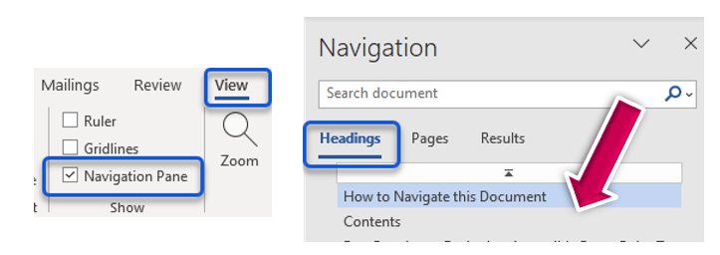](https://youtu.be/Vx8Lz3oRRRY?si=8VYorrKAq1m4AUuU)

## Before you Begin!

Take a moment to view a short video to understand the information presented in this workbook.

General Services Administration (**GSA**) video (**8min 18sec**) – **Creating PowerPoint Templates**.

Click the image below to view the video.

[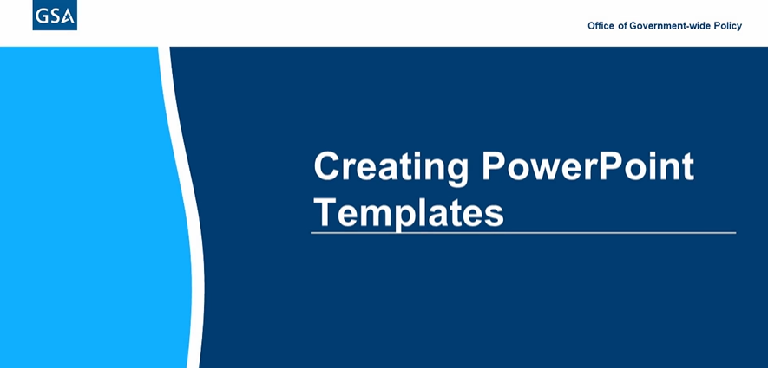](https://www.section508.gov/create/presentations/creating-powerpoint-templates)

Table of Contents

About this Program ii

Responsibilities ii

Supplemental Documents ii

How to Navigate This Document iii

Before you Begin! iv

Template Designer - Responsibilities 1

Document Author – Responsibilities 1

PowerPoint Window – Design for Accessibility 2

Slide Master View 5

Slide Master Ribbon 5

Add Accessible Attributes and Elements 5

Slide Master Panes 6

Add a Background Style (Optional) 6

Select a Theme (Optional) 7

Decorative Elements Must be Marked as Decorative 8

Create a Decorative Element 8

Select or Create an Accessible Color Palette 10

Edit or Delete a Color Palette 11

Shared Color and Font Palettes 11

WCAG 1.4.3 Color Contrast Requirement 11

WCAG 1.4.1 – Use of Color Requirement 12

Color Contrast Tools 13

Select an Accessible Font Palette 14

Create an Accessible Font Palette 15

Best Practices for Selecting an Accessible Font 15

508 Requirements Met – Fonts 16

Apply Lists 17

Change List Item Sub-headings 17

Use the Ruler to Align the List of Items 18

508 Requirements Met – List Items 19

Set Document Language, if Applicable! 20

Set Proofing Language 20

508 Requirement Met – Language 20

Change Paragraph Spacing 21

508 Requirements Met – Paragraphs and Spacing 21

Add a Logo 22

How to access the Alt Text Box 23

Use the Title Placeholder to Prompt for Accessibility 24

Examples of Unique Titles 24

508 Requirements Met – Slide Titles 25

Insert Slide Numbers 25

Slide Master View – Reading Order Pane 26

Close Slide Master View 28

Check your work! 28

Run the Microsoft Accessibility Checker 29

Package and Distribute – Template Designer 30

Create a PowerPoint Template 30

Retrieve PowerPoint Template 30

Do Not Save the Template as a Theme 31

Sample Message to Author 31

Customizing Slide Layouts (Slide Master View) 32

Insert Slide Master 33

Insert a Layout 33

Duplicate a Layout 33

Delete a Layout 34

Rename a Layout 34

Copy Layouts from another presentation! 35

Placeholders 38

Title and Footer Placeholders 38

Content Placeholder 39

Text Placeholders 39

Align Placeholders 45

Copy a Placeholder 46

Picture Placeholders 46

Insert a Chart Placeholder 52

Insert a SmartArt Placeholder 53

Insert a Table Placeholder 54

Troubleshooting Placeholders 55

Decrease File Size 55

Picture Placeholders 55

Table Placeholders 56

Chart Placeholders 57

Media Placeholders 58

Accessibility Checker Triggers 60

Check Reading Order – Pictures 60

Check Reading Order – Charts and Tables 63

Missing Table Header 63

Miscellaneous Placeholder Issues 64

Crop, Insert, Replace Picture Placeholders 64

Can’t View Picture 65

PowerPoint Opens in Slide Master View 66

How to Resolve the Microsoft Accessibility Checker Inspection Results 67

Unable to Run the Microsoft Accessibility Checker 68

Check Reading Order 68

Reading Order Anomalies 69

Think Outside the Box! 70

Default Section Name 72

Duplicate Section Name 72

Duplicate Slide Title 73

Hard-to-Read Text Contrast 74

Color Contrast Tools 74

Missing Audio or Video Subtitles * 76

Transcript (.VTT / .SRT) File Formats 77

Missing Object Description* 78

Guidelines for Writing Alt Text 78

Missing Slide Title 81

Missing Table Headers* 83

Review Auto-Generated Description* 84

Turn Off Automatically Generated Alt Text 84

Use of Merged or Split Cells* 85

Microsoft Accessibility Checker Limitations 85

Standard HHS Checklist Requirements 86

Document Language 86

Document Properties 87

Filename Conventions 87

Filename Examples 88

Resources – Filename Conventions 88

Flashing or Flickering Text 89

Hyperlinks 90

Best Practices – Hyperlinks 91

Print Grayscale 92

Restricted Documents 92

Transitions & Animations 92

508 Resources 94

Test Accessibility – Narrator Screen Reader 94

Microsoft Accessible Templates 94

Download Accessible Templates– 95

Free Online Microsoft Courses 95

Accessibility Tools 95

508 Resources - Laws, Guidance, Standards, and Training 96

*Indicates the title of the error flagged by the Microsoft Accessibility Checker has changed.

## Template Designer - Responsibilities

It is the responsibility of the template designer to create an accessible template that can be used within your office.

To accomplish this task, the Template Designer can add the following attributes in the Slide Master view that comply with the Section 508 Standards and HHS Checklist Requirements.

**Open PowerPoint. Click View > Slide Master.**

* Select or create an accessible Font palette.
* Select or create an accessible Color palette.
* Add a hierarchy to Lists (bullets and numbering).
* Align Lists.
* Add the appropriate paragraphs and spacing between text.
* Apply Slide Numbers using the Header and footer options.
* Insert Placeholders (Text, Pictures, etc.).
* Align placeholders.
* Add logos or decorative elements to the layout.
* Apply the appropriate alternate text to logos and decorative elements.
* Add prompts for the user (document creator). For example, “Click to enter a “unique” title.”
* Check and correct the Reading Order of the Layout.
* Close Slide Master view. Preview your work in Normal view.
* Upon completion, package and distribute the template.

Each item listed above complies with Section 508 requirements for creating an accessible electronic document. See the HHS Checklist Requirements section in this document.

## Document Author – Responsibilities

The Author will learn how to properly insert a new slide in the presentation and apply the appropriate HHS, Section 508, and Microsoft Accessibility Checker Results.

# PowerPoint Window – Design for Accessibility

You will see the Title Bar at the top of the window. It displays the name of the application and the file currently in use.

Screenshot of PowerPoints Title Bar.

Title Bar - The Quick Access menu options, the search field, and the presentation title are within the Title Bar.

Screenshot of the menu bar.

Menu Bar - The Menu Bar provides additional options and functions.



Ribbon - The Ribbon (Toolbar) contains various formatting options. Most of these options are available in the Slide Master view.

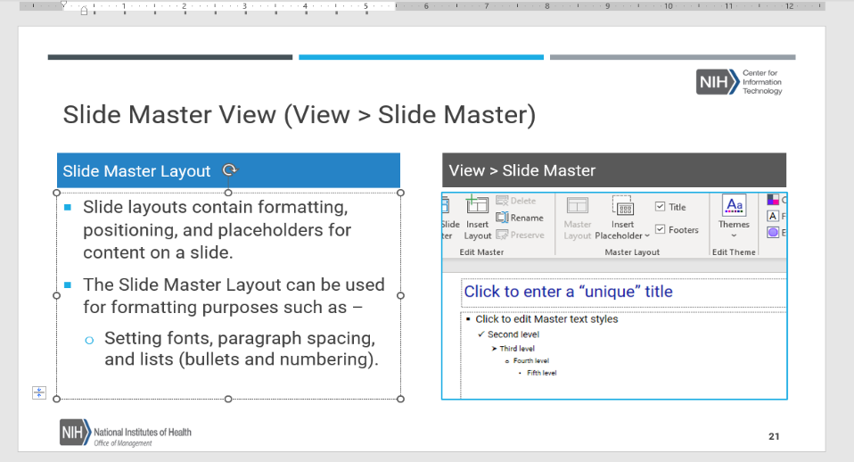

Layout Window – The layout window contains a blank canvas. This is the layout pane for the placeholders. Placeholders are used for text and various objects such as pictures or tables. The layout pane is active in both Slide Master and Normal view.

Screenshot of the status bar

Status Bar – Located at the bottom of the screen. When activated, it provides access to the Accessibility Checker Inspection Results. Icons appear on the status bar’s right, allowing users to toggle between various views.

PowerPoint Views– There are several views in PowerPoint –

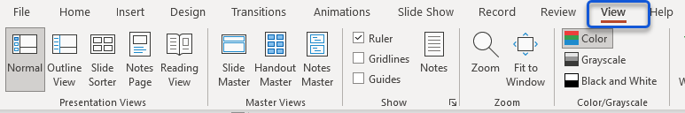

|  |  |
| --- | --- |
| View > Normal.  Normal view is the editing mode where you’ll work most frequently. |  |
| View > Outline View.  Outline view - this view works well with Assistive Technology.  This view displays text only, which is excellent for printing. |  |
| View > Slide Sorter.  Slide Sorter view allows you to rearrange slide placement. |  |
| View > Notes Pages.  Notes Pages view allows you to view speaker notes.  You can also print this view and save it as an RTF file. |  |
| View > Slide Master.  Slide Master view is where you can format each layout to accommodate a specific format.  This is also where you can apply global accessibility features. |  |

Resource: [Choose the right view for the task in PowerPoint](https://support.microsoft.com/en-gb/office/choose-the-right-view-for-the-task-in-powerpoint-21332d8d-adbc-4717-a2c6-e25a697b40e9).

## Slide Master View

Slide Master view is a unique feature in PowerPoint that allows you to quickly modify your presentation's slide layouts. The edits in slide master affect every slide in the presentation. You can also modify individual slide layouts.

Open a blank PowerPoint Presentation - File > New > Blank Presentation. Add a descriptive filename and save it to OneDrive.

To access the Slide Master - Click View > Slide Master.

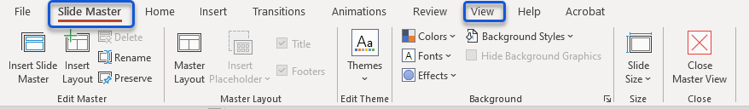

## Slide Master Ribbon

The Slide Master Ribbon provides access to attributes such as placeholders, color and font palettes, and background styles.

Also, while in Slide Master mode, you can toggle between other menu options, such as Home, to set paragraph spacing or the Review tab to Check the Reading Order of the layout.

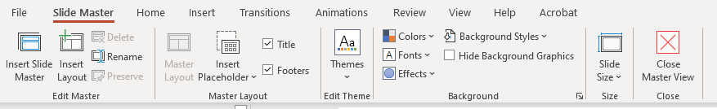

## Add Accessible Attributes and Elements

Click on the Slide Master to select it. A box appears around selected layouts. Click anywhere within the workspace. Now, you are ready to start designing your template!

## Slide Master Panes

The Slide Master Pane has two (2) views.

|  |  |
| --- | --- |
| **Thumbnails**  The **first** view contains a **thumbnail** view of each slide layout, where you can duplicate, rename, or delete a layout. | **Workspace**  The **second** is the **workspace** view, where you can insert/remove placeholders and content (i.e., design elements or logos) for a specific layout. |

## Add a Background Style (Optional)

To change the background color of every slide in the Slide Master view, select the Slide Master, then click Background Styles, and select the appropriate style.

To change the background color of a specific slide in the Slide Master view, select the appropriate slide layout (i.e., Title), then click Background Styles and select the appropriate style.

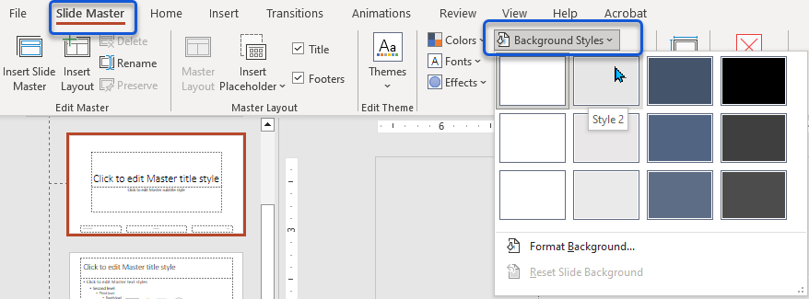

For more options, click the [Format Background](https://youtu.be/MsUbU1rhPmo?si=RcZ6y4rfs2kynRwm) (short video - **01min 57sec**) option to add a solid, gradient, pattern, picture, or textual fill. Remember, you can perform the same actions in Slide Master and Normal views. Ensure you are in Slide Master view before changing the Background Styles.

### Select a Theme (Optional)

A theme is a predefined set of colors, fonts, and visual effects applied to your slides for a unified, professional look. View > Slide Master > Themes > Select the appropriate theme or browse for themes.

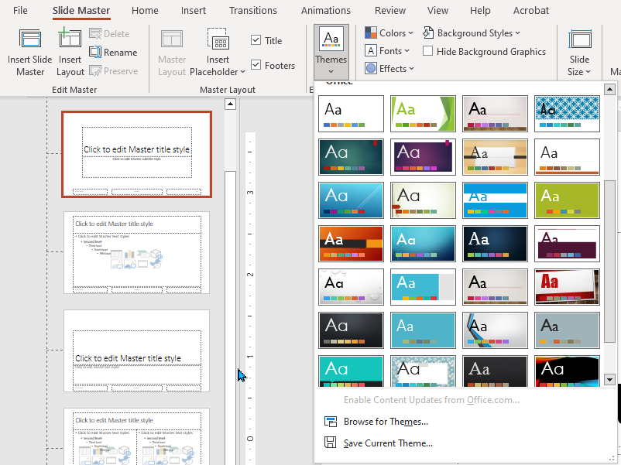

See also – [Customizable Design Templates](https://create.microsoft.com/en-us/templates/themes).

### Decorative Elements Must be Marked as Decorative

Whether using a Theme or creating decorative elements, the decorative element(s) must be marked as decorative.

Right-click the decorative element and click **View Alt Text**. Check **Mark as decorative**.

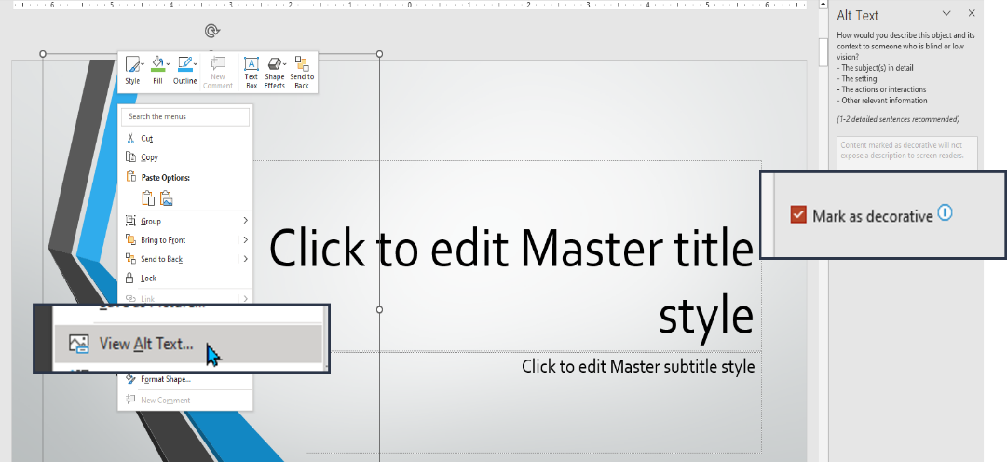

### Create a Decorative Element

To create a decorative element, in **Slide Master** view, click on the **Insert** tab, click on the **Shapes** icon, and select a shape.

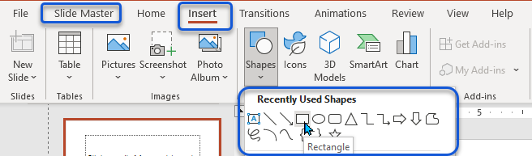

|  |  |
| --- | --- |
| Once you insert the shape, the Shape Format menu option will appear. |  |
| You can add shape fill, line color, or shape effects to the selected placeholder or element. |  |
| The next thing you must do is mark your decorative elements as decorative. Right-click the decorative element and click View Alt Text. |  |
| In the Alt Text box, check the ‘Mark as decorative’ box. |  |

Content marked as decorative will not expose a description to screen readers.

Information iconIf you **do not** want the **decorative** element to appear on the **Master** **Title** **Slide**, do not add it to the Slide Master Layout. **Add** the decorative element to the **Title and Content Layout**.

## Select or Create an Accessible Color Palette

View > Slide Master > Colors allows you to select a pre-defined color palette or create, edit, or customize a palette.

The Create New Theme Colors dialogue box will appear.

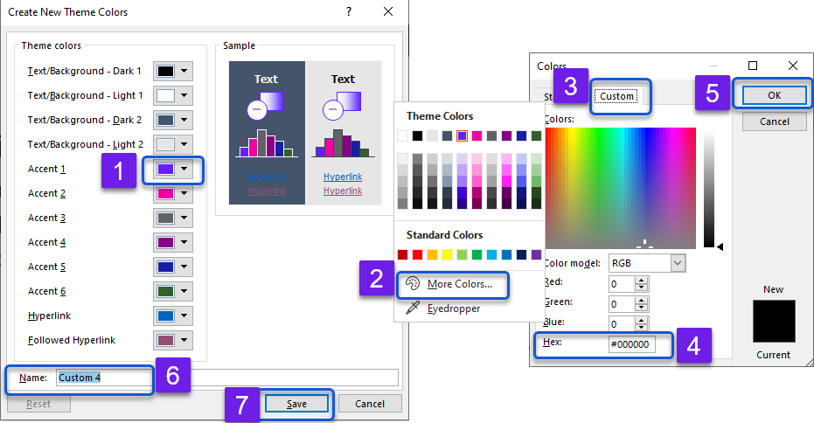

**Step 1)** Select the down arrow next to the appropriate **Accent** color.

**Step 2)** When the **Theme’s Colors** dialogue box appears, click **More Colors**…

**Step 3)** Click the **Custom** tab.

**Step 4)** Enter the appropriate **Hex Code**.

**Step 5)** Click **OK**. Repeat this process for each additional **Accent Color**.

Upon completion –

**Step 6)** **Name** the palette.

**Step 7)** Click **Save** to save your newly created color palette.

### Edit or Delete a Color Palette

**View** > **Slide Master** > **Colors**.

|  |  |
| --- | --- |
| While in Slide Master view, click the down arrow next to the Colors option.  Right-click on the color palette you want to edit or delete. Click the appropriate response. |  |

### Shared Color and Font Palettes

Color and Font palettes are shared across Microsoft Office 365 products. You can access a customized palette in Word, PowerPoint, Outlook, and Excel.

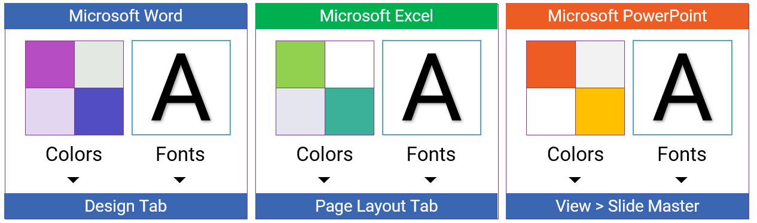

Microsoft Word – Design tab. Microsoft Excel – Page Layout tab. Microsoft PowerPoint – View > Slide Master. Microsoft Outlook – Open an email message and click in the body of the email to activate the menu options. Click Format Text > Change Styles > Colors > Fonts, whichever is applicable.

### WCAG 1.4.3 Color Contrast Requirement

Creating an accessible color palette complies with the Web Content Accessibility Guidelines Standard (**WCAG**) **1.4.3**. The visual presentation of text and images of text has a contrast ratio of at least 4.5:1, except for the following:

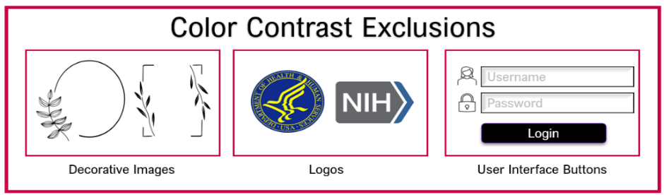

Large Text

Large-scale text and images of large-scale text have a contrast ratio of at least 3:1.

Incidental

Text or images of text that are part of an inactive user interface component, pure decoration, not visible to anyone, or part of a picture containing significant other visual content have no contrast requirement.

Logotypes

Text that is part of a logo or brand name has no contrast requirement.

### WCAG 1.4.1 – Use of Color Requirement

Color cannot be the only means to elicit a response or distinguish an element.

|  |  |
| --- | --- |
| The first set of traffic lights show red, yellow, and green.  The second set of traffic lights each light shows a person in a different pose along with a word. Red - Stop, Yellow - Wait, and Green - Go. | [Use of Color Requirement 1.4.1](https://www.w3.org/TR/UNDERSTANDING-WCAG20/visual-audio-contrast-without-color.html) - Color is not the only visual means of conveying information, indicating an action, prompting a response, or distinguishing a visual element. |

### Color Contrast Tools

There are several Color Contrast Tools available online.

|  |  |
| --- | --- |
| WebAIM (Web Accessibility in Mind)  Color Contrast Checker (online) [WebAIM: Contrast Checker](https://webaim.org/resources/contrastchecker/)  Option 1: Enter the [Hex Code](https://www.color-hex.com/) of the foreground color (text) or background color (slide).  Option 2: Use the Lightness sliders to obtain the code of an accessible color combination. |  |
| The TPGi Colour Contrast Analyzer ([CCA](https://www.tpgi.com/color-contrast-checker/)) is a free downloadable program that allows you to use a [color picker](https://youtu.be/agCzn4gdRyY?si=oLL3g8h2ka3sFDQD) (short video 2min 16sec) to determine the accessibility of color combinations within your document. | Desktop computer monitor displaying text Contrast Failure with the Colour Contrast Analyzer checking for the color contrast ratio. |

**Optional Tool** developed in the Contract Data Management Program (**CDMP**).

This tool provides the color contrast ratio of accessible color combinations, given that the background color is **white** or **off-white**. If the background color of your document is other than white or off-white, then use one of the color contrast tools to verify it meets the Color Contrast Standard.

Open the spreadsheet and use the slicer to view a specific color family.

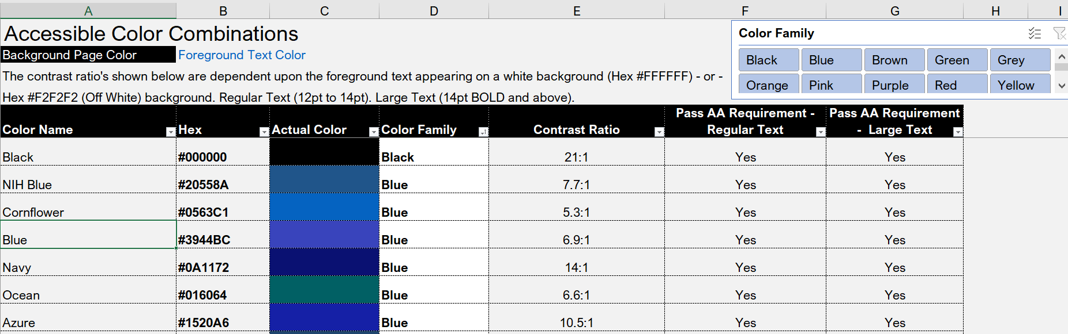

Use this spreadsheet as a master file to store accessible color combinations. Feel free to add additional colors.

## Select an Accessible Font Palette

Click View > Slide Master > Fonts. The Custom dialogue box will appear. Select the appropriate Font group.

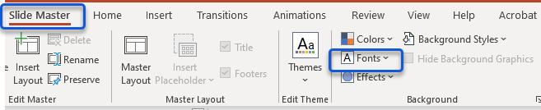

### Create an Accessible Font Palette

Click the down arrow next to the Fonts icon.

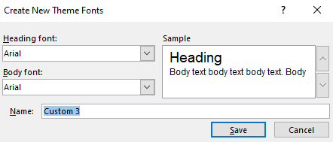

In the Create New Theme Fonts dialogue box, select a **heading font and then select a body** font. **Rename** the palette and click **Save**.

### Best Practices for Selecting an Accessible Font

Your font choice can positively or negatively impact the person reading your printed and digital communications. Some fonts are easier to read than others; if chosen well, the right font can help you get the message across.

Many people don’t know that some fonts can be inaccessible to disabled people, particularly those with visual or learning disabilities.

Serif-type fonts are considered accessible because they do not have decorative lines or points.

Use relative units for font size **Large Point 18pt minimum for PowerPoint**. You can adjust the font size in the Slide Master view.

Limit font variations such as bold (strong), italics (emphasis), and ALL CAPITAL LETTERS.

Don’t rely on the appearance of the font (color, shape, font variation, placement, etc.) to convey meaning.

Avoid blinking or moving text.

The font size, type, weight, and color can play a role in determining the accessibility of the font.

|  |  |
| --- | --- |
| The minimum font size in Microsoft Word, Outlook, and Excel should be 12pt.  12pt – Normal is considered regular text.  14pt Bold is considered large text, and  18pt is recommended for PowerPoint.  You can set a default font in all Microsoft Office 365 programs.  In Microsoft PowerPoint, use the Slide Master (View > Slide Master) view to apply the appropriate font size, a minimum of 18pt.  Color Contrast Analyser ([download](https://www.tpgi.com/color-contrast-checker/)). | [Example of the Color Pint - HE #F200A7 - 12pt regular text - Failed inaccessible. However, 14pt bold of the same color is accessible.](https://www.tpgi.com/color-contrast-checker/) |

### 508 Requirements Met – Fonts

**HHS ID 5G** - The document is readable and functional when the text is resized up to 200 percent.

**HHS ID 5H** - Text is used instead of images of text (unless it is essential for conveying information).

## Apply Lists

**View** > **Slide** **Master**. On the Slide Master workspace, click within the Text Placeholder next to the first list item.

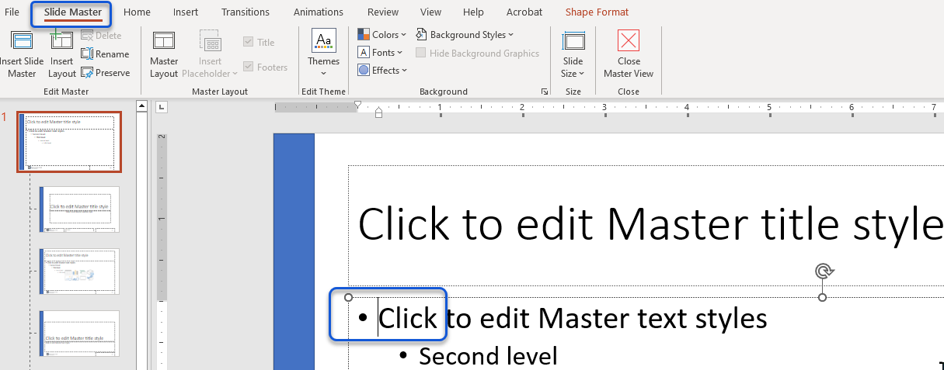

### Change List Item Sub-headings

List Items should display a unique marker.

|  |  |
| --- | --- |
| View > Slide Master > Home > Bullets > Click the arrow to review options. |  |
| Click within the first list level – Click Home > Bullets > and select the Filled Square [⏹ ] icon.  Click within the second list level - Click Home > Bullets > and select the Checkmark [✓ ] icon. |  |
| Repeat this process for each list item in the Slide Master layout.  The changes you make on the Master Slide layout will flow to each layout in the Slide Master view. | Screenshot of list items showing a different bullet icon at each level. |

### Use the Ruler to Align the List of Items

**Note:** The ruler displays an independent indent marker for each level if the text contains more than one level of bulleted or numbered items.

|  |  |
| --- | --- |
| View > Slide Master > View > check [Ruler](https://support.microsoft.com/en-us/office/adjust-the-indent-in-a-bulleted-or-numbered-list-on-the-ruler-8ee53443-2bb7-4d55-95c9-620b2160b8b8). |  |
| Place the cursor between the Checkmark icon [ ✓ ] and the words “Second Level” to activate the ruler. |  |
| The top marker (1) shows the indent position of the **bullet** or **number**.  The bottom marker (2) shows the indent position of the **text**.  You can adjust either as needed. | Ruler |
| In the ruler, the bottom (2nd) marker indents the position of the text.  Click the marker and drag it towards the desired position (i.e., 1).  Repeat this process for each level as needed. |  |

### 508 Requirements Met – List Items

HHS ID 4C - The bullets. A numbering or multi-level list icon is selected on Home > Paragraph for all list items.

HHS ID 4D - A bullet or numbering style (then the parent style) is selected for sub-list items.

W3C Web Accessibility Initiative (**WAI**) – [Module 2: Structure](https://www.w3.org/WAI/curricula/content-author-modules/structure/).

## Set Document Language, if Applicable!

Microsoft PowerPoint Language setting defaults to **English**. If the presentation is in a language other than English, follow the steps below.

While in Slide Master Mode (View > Slide Master), Click Review > Language > Language Preferences > select the appropriate Language > click OK.

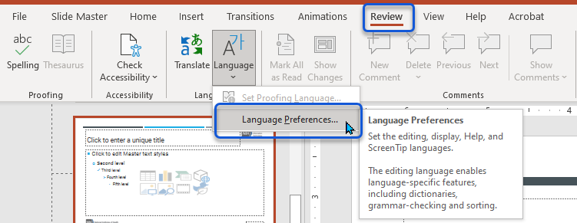

Click OK on the message – Please restart Office so language changes can occur.

If the presentation is part English and another language, then the Author must set the Proofing Language in Normal mode.

### Set Proofing Language

Review > Language > Set Proofing Language > Select the appropriate Language.

### 508 Requirement Met – Language

**HHS ID 10A** – Review > Language > Language Preferences displays the appropriate language for the presentation.

**HHS ID 10B** – The language of the slide content in a different language is identified through Review > Language > Set Proofing Language.

## Change Paragraph Spacing

View > Slide Master > Home > Paragraph. Click the **options** icon to reveal the Paragraph dialogue box.

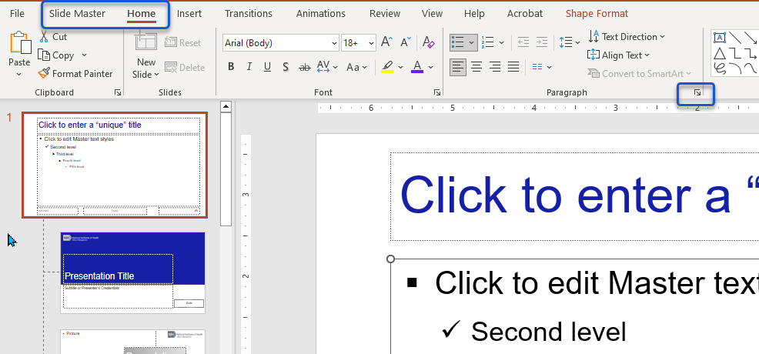

|  |  |
| --- | --- |
| General Alignment should be Left.  Do not use Justified alignment.  You can adjust the Spacing (Before or After) text.  Consider adjusting the Line Spacing.  Upon completion, click OK. |  |

### 508 Requirements Met – Paragraphs and Spacing

**HHS ID 4A** - Blank lines, tabs, or spaces are not used for the structure.

[W3C Justification](https://www.w3.org/WAI/GL/low-vision-a11y-tf/wiki/Justification) – Justification impacts readability and tracking.

[W3C Spacing](https://www.w3.org/WAI/GL/low-vision-a11y-tf/wiki/Spacing) - The space between lines in a text block is called leading. Some people need more space between lines to be able to read text. Line spacing also helps with tracking.

## Add a Logo

Copy and paste a logo into the Master Slide layout. Then, add the appropriate alt text.

If you do not want the logo to appear on the Master Title Slide, add the logo to the Title and Content Layout in the Master Slide view.

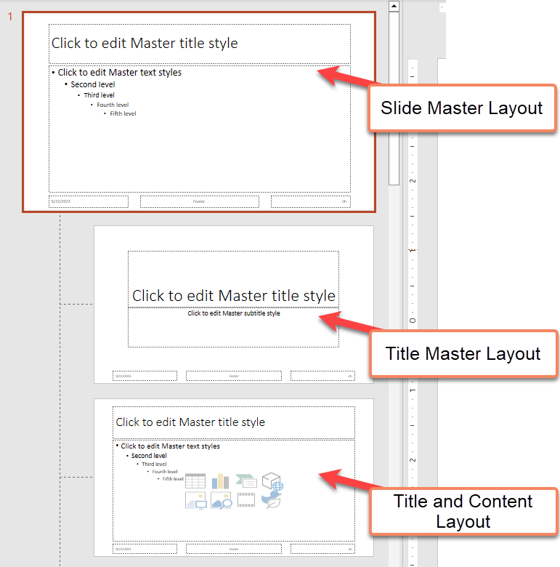

**Note:**

The **Template Designer** applies the appropriate alternate text to objects in the **Slide Master** view.

The **Author** is responsible for applying the appropriate alternate text to objects in **Normal** view. The Microsoft Accessibility Checker will flag objects with a Missing Object Description.

### How to access the Alt Text Box

For logos or images containing pertinent information – add the appropriate alt text.

|  |  |
| --- | --- |
| Right-click the logo and click View Alt Text. |  |
| In the Alt Text box, enter the appropriate alt text.  For example - NIH – National Institutes of Health, Office of Management |  |

The Alt Text Box holds up to **255** characters. If the object cannot be adequately described in 255 characters, add a link to an accessible alternate version.

There are several different ways to access the Alt Text box.

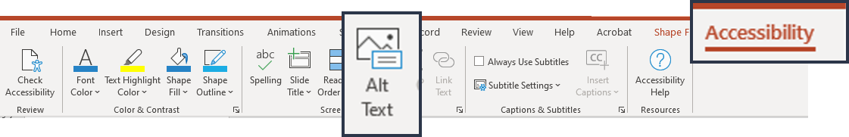

* Right-click the object and click View Alt Text.
* Click Review > Check Accessibility > Alt Text.
* Click Review > Check Accessibility > Missing Object Description > Add a Description.
* Click Accessibility > Alt Text.

[POET Tool](https://poet.diagramcenter.org/how.html) – Helps you write alternative text for various objects—charts, SmartArt, processes, infographics, etc.

## Use the Title Placeholder to Prompt for Accessibility

The prompts can be changed to alert the Author of opportunities to make the presentation accessible.

Users rely on titles to know where they are in the slide deck. The tip “Click to enter a “unique” title” reminds the document creator that each slide must contain a unique title.

View > Slide Master, click within the Title Placeholder, and type – Click to enter a “unique” title.

Next, copy (CTRL+C) and paste (CTRL+V) the ‘prompt’ in each Title Placeholder in the Slide Master view.

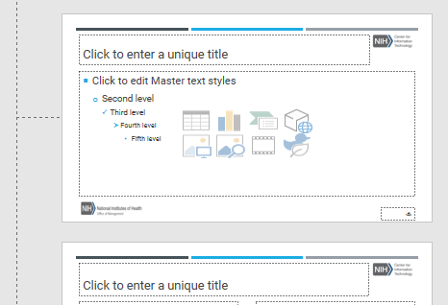

### Examples of Unique Titles

**Example 1:** Use a number or letter to differentiate titles—for example, Team 1, Team 2, Team 3.

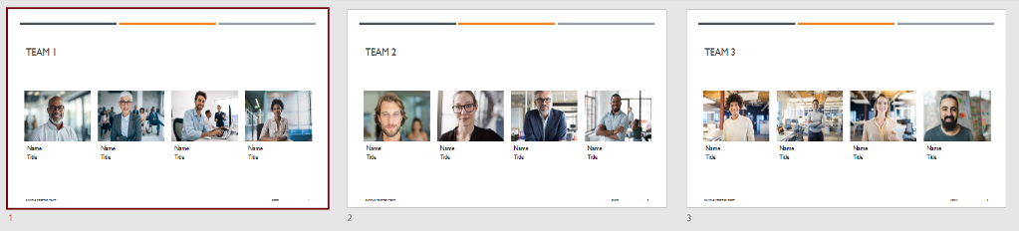

**Example 2:** Add supplemental information, for example (continued) or as displayed in the illustration above (Content, Additional Content).

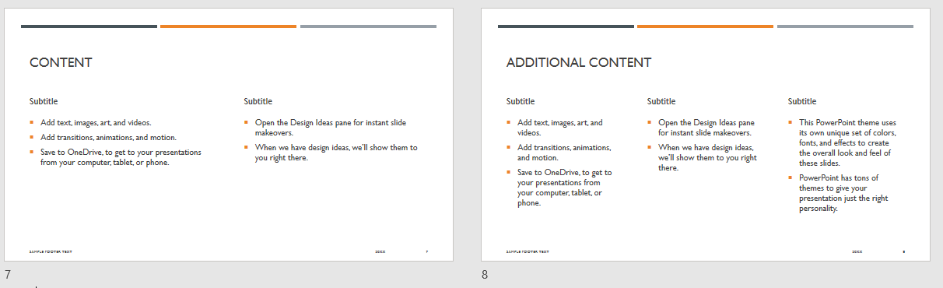

### 508 Requirements Met – Slide Titles

**HHS ID 9E** - Slide titles are unique and informative. Only duplicate slide titles if the structure provides adequate differentiation between them.

## Insert Slide Numbers

Inserting the slide number in the Master Slide view will help to prevent the Author from triggering the Check Reading Order.

|  |  |
| --- | --- |
| View > Slide Master. Click the Slide Master layout. |  |
| Click Insert > Slide Number. |  |
| In the Header and Footer dialogue box, check Slide Number.  Check. ‘Don’t show on the title slide.’  Click Apply to All. |  |

## Slide Master View – Reading Order Pane

The Accessibility Checker will not pick up on reading order issues in the Slide Master view. Therefore, it is vital to check and correct the Reading Order in the Slide Master view.

Click Review > Check Accessibility > Reading Order Pane.

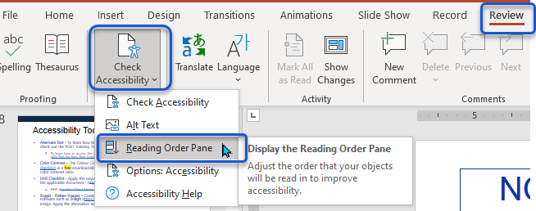

Click on each item in the Reading Order Pane. Notice how each time you click an item, it highlights the corresponding placeholder in the slide layout.

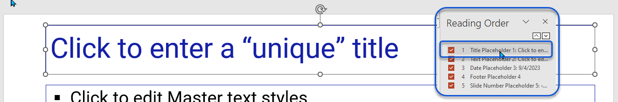

This will allow you to compare what you see on the screen to how PowerPoint interprets the reading order.

|  |  |
| --- | --- |
| In the Reading Order Pane, click an item (i.e., 1 Title Placeholder), then use the up/down arrows to move the items into the correct reading order. |  |

The Check Reading Order and the Slide Master Layout should read as follows. **Check Reading Order** – **1)** Title Placeholder, **2)** Content Placeholder, **3)** Date Placeholder, **4)** Footer Placeholder, and **5)** Slide Number Placeholder.

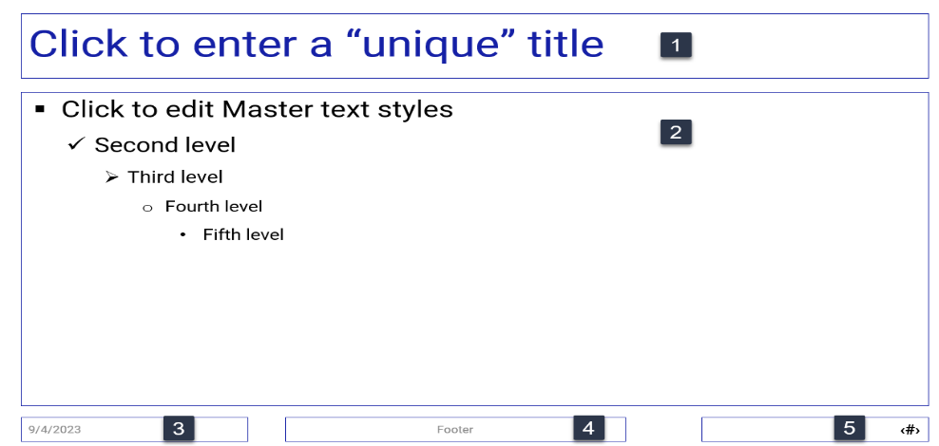

## Close Slide Master View

Close the Slide Master view before checking your work in Normal view.

|  |  |
| --- | --- |
| Click the Slide Master tab and click Close Master View. |  |

Don’t forget to save your work.

## Check your work!

After completing the slide layouts, check your work before packaging and distributing the template to users. For example, add **sample** text, images, or charts in the layout. If you need to adjust placement or alignment, return to the Slide Master view and make the necessary adjustments.

|  |  |
| --- | --- |
| In Normal view, click Home > New Slide. |  |
| Select the appropriate Layout.  For testing purposes, make sure that you insert each layout in Normal view. |  |

Now, you are ready to run the Accessibility Checker.

### Run the Microsoft Accessibility Checker

Next, run the Accessibility Checker to avoid triggering the Check Reading Order error.

|  |  |
| --- | --- |
| Option 1: Click Review > Check Accessibility > Reading Order Pane.  Option 2: Click Review > Check Accessibility > Check Reading Order > Verify Object Order. |  |
| In the Accessibility Inspection Results pane, if the Check Reading Order is not displayed. Great job.  Note: Some errors cannot be addressed with a Template. The Author must address issues not corrected by the Template – for example, Missing Object Description and Slide Title. |  |

If the Check Reading Order error is triggered, make the correction in Normal view, write down the order, then go to Slide Master view and correct the Reading Order Pane.

## Package and Distribute – Template Designer

Now, you are ready to package and distribute your document. A few things must be done to ensure the user gets the most out of the template.

* Add the appropriate Accessibility features, such as fonts, paragraph spacing, lists, and color contrast, to the Side Master view.
* Check Layout designs to ensure the Check Reading Order is not triggered in Normal view.
* Add sample information to the placeholders to ensure the placement is accurate. Readjust in Slide Master view. Be sure to remove the sample slides before distribution.
* Add a message to the author and describe how to insert a Layout (Home > New Slide).

### Create a PowerPoint Template

Save the file as a (*.**POTX** [PowerPoint Template]) file. File > Save As or Save a Copy. In the drop-down, select PowerPoint Template (*.**POTX**).

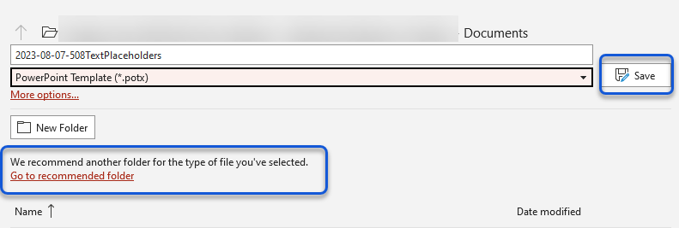

Click Go to the recommended folder. In **File Explorer**, click **Save**.

### Retrieve PowerPoint Template

|  |  |
| --- | --- |
| File > New > Custom > Custom Office Templates. Select the appropriate template. |  |

### Do Not Save the Template as a Theme

Although you can use the Theme in Slide Master view to create a professional-looking template, you should not save the Template as a Theme. Themes do not retain the reading order. Always save the Template as a Template.

### Sample Message to Author

Suggested Instructions - How to Use this Slide Deck.

Click **Home** > **New Slide** > Select the appropriate layout style.

* Use slide layouts – Do Not Insert Text Boxes!
* If you are unable to fit the contents within a placeholder.
* Apply the “Think Outside the Box” method.
  + Insert the Title and Content Layout and enter the appropriate alt text.
  + Save the original design in a separate presentation.
  + Flatten the image and overlay it over the Title and Content Layout.
  + Mark the Image as Decorative.
* Run the Accessibility Checker (Review > Check Accessibility) to address the Inspection Results and apply the appropriate HHS Checklist requirements before posting or distributing the presentation.
* Information for resolving the Accessibility Inspection Results can be found on the Contract Data Management Program ([CDMP](https://oalmsps.od.nih.gov/DDO/CDMP/Directory/_layouts/15/start.aspx#/SitePages/Home.aspx)) site on the [Office 365 Digital Accessibility](https://oalmsps.od.nih.gov/DDO/CDMP/508/_layouts/15/start.aspx#/SitePages/Office%20365%20Digital%20Accessibility.aspx) page.
  + You must be connected to a **VPN**. At sign-in, select Windows Authentication.

# Customizing Slide Layouts (Slide Master View)

As a Template Designer, PowerPoint offers many features and functions to help you create professional dynamic templates.

The Master Slide controls the fonts, colors, spacing, slide number, and any other element included in the Master Slide. Layouts are customized offspring of the Master Slide. There is only **one (1) Master Slide**. However, there are **many** layouts.

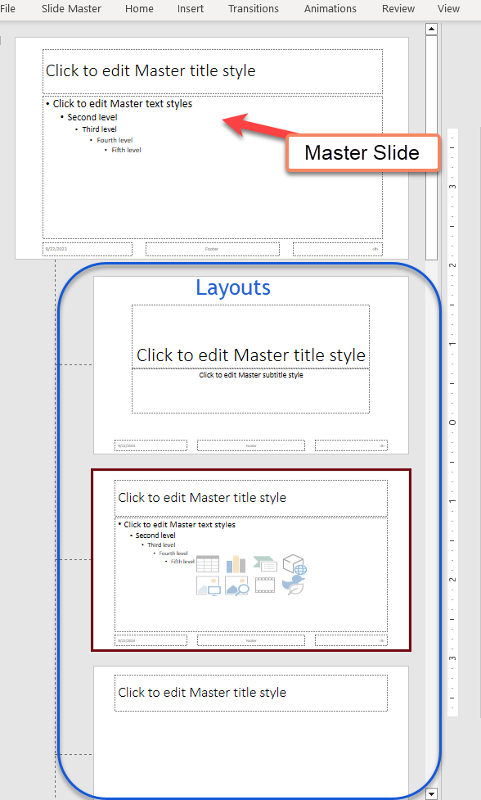

**Resource:** [Video Tutorial](https://youtu.be/mUdECnUow70?si=7gwWhpNmbc1zsTfb) (**1hr 38min 23sec**). PowerPoint Template Master Class Part One – Template Setup.

## Insert Slide Master

When you select Insert Slide Master, you create a new master slide set of layouts independent of the current layout.

|  |  |
| --- | --- |
| View > Slide Master. In the Edit Master Group, click Insert Slide Master. |  |

When you select Insert Layout, you insert a layout with the title and footer placeholders. This layout can include text, pictures, tables, etc., and placeholders.

### Insert a Layout

|  |  |
| --- | --- |
| View > Slide Master. In the Edit Master Group, click Insert Layout. |  |

### Duplicate a Layout

|  |  |
| --- | --- |
| View > Slide Master. Right-click the appropriate layout and click Duplicate Layout. |  |

### Delete a Layout

Note – You cannot delete a layout that is in use in Normal view.

|  |  |
| --- | --- |
| View > Slide Master. Right-click the appropriate layout and click Delete Layout. |  |

### Rename a Layout

Be cognizant of the name because it will appear as a selection in the New Slide Layout menu option. Be succinct but descriptive.

|  |  |
| --- | --- |
| View > Slide Master. Right-click the appropriate layout and click Rename Layout. |  |

### Copy Layouts from another presentation!

**Why reinvent the wheel?** Copy layouts from other presentations. If you do so, check the reading order and test the slide before distribution.

|  |  |
| --- | --- |
| Open the presentation you want to copy from – for example, the [Catalog](https://www.section508.gov/iaaf/)- and click View > Slide Master. |  |
| Find and select the layout you want to copy into your presentation. |  |
| Next, right-click the selection and click Copy. |  |
| Open the presentation into which you want to insert the layout. Click View > Slide Master. |  |
| Place the cursor where you want to insert the layout. |  |
| Click the Home menu option and the down arrow next to Paste. |  |
| Select Use Destination Theme (a) or Keep Source Formatting (paintbrush). |  |
| Use the destination theme to stay aligned with the format of the current presentation.  You may have to readjust or realign placeholders. |  |
| Keep Source Formatting preserves the formatting of the presentation being copied from and includes a separate Master Slide. |  |

#### Paste Options

Here are a few resources to help you understand the many options that Paste has to offer.

[PowerPoint](https://www.youtube.com/watch?v=iolpccOoNtU) – Paste Options – video (7min 56sec)

[Excel](https://support.microsoft.com/en-us/office/paste-options-8ea795b0-87cd-46af-9b59-ed4d8b1669ad) – Paste Options – thoroughly examine the many paste options in Microsoft Excel.

[Word](https://youtu.be/2t1ujvVisSE?si=tNhe4_QnBtC_K_lU) – Paste Options – video (1min 18sec)

## Placeholders

Placeholders are designed to contain information such as text, tables, pictures, etc. A placeholder can be re-shaped or contain visual effects. Please take a moment to become familiar with placeholders and how they can enhance the appearance of your presentation. Learn how to mix and match or place multiple placeholders within a layout.

Also included in this section are warnings and suggested resolutions for potential issues with some placeholders.

### Title and Footer Placeholders

In Slide Master view, you can activate the Title and Footer Placeholders by placing a checkmark next to the placeholder you want to add to the slide layout (Title or Footer). Do not use Text Boxes to create the Title Placeholder or the Slide Number Placeholder.

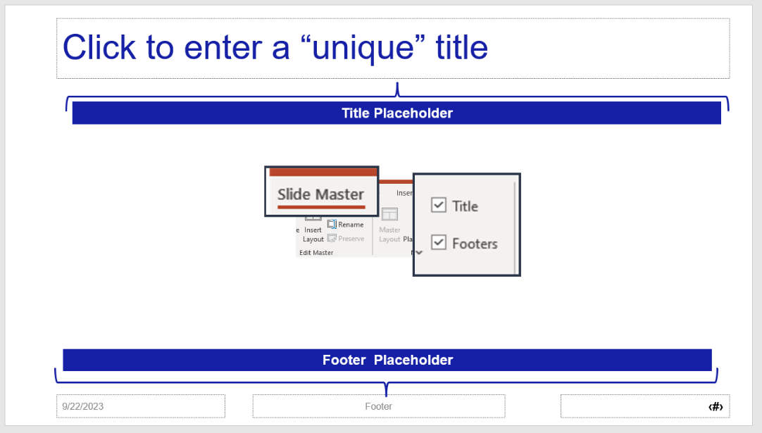

The Date, Footer, and Slide Number Placeholders can be activated by checking the Footer box in the Master Layout group. You can keep or delete the Date and Footer placeholders. **You should always keep the Slide Number Placeholder.**

### Content Placeholder

The Content Placeholder is the catch-all for all content. The Content Placeholder can be used to insert Text, Tables, Charts, SmartArt, 3-D Models, Pictures, Online Images, Media, and Icons.

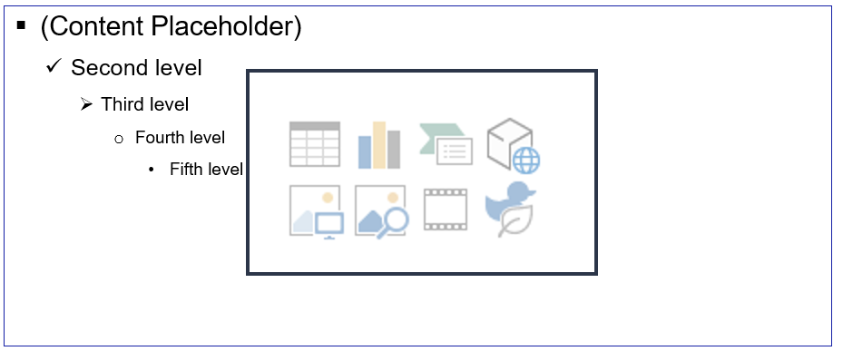

The difference lies in the behavior of the placeholders. When you insert a photo into a content placeholder, the placeholder changes to fit the photo. When you insert a picture into a picture placeholder, it keeps the dimensions of the placeholder.

### Text Placeholders

There are several uses for Text placeholders. Text placeholders should be used instead of Text boxes. The information contained in the Text placeholder can be seen in the Outline view. This information is beneficial to all users, especially those using assistive technology.

Take a moment to review the [Shapes vs. Text Boxes vs. Placeholders](https://youtu.be/09Fl6P-vQIw?si=S8wh-ShRsJPKMazt) (Microsoft PowerPoint) (video **15min 27sec**). Please note that instead of using the Text Box, please insert a Text Placeholder. You can apply the same principles to both options presented in the video.

* Text placeholders can be used as **labels** to help identify other content, such as pictures.
* Text placeholders can be used as **captions** for tables or charts.
* Text placeholders can be used as a **resource** or **source** **link** to provide users with more information.
* Text placeholders can be used as a **sub-title** or a place to store **contact information**.
  + Text placeholders can be **resized**, **re**-**shaped**, and contain a **different** **font**.
  + You can **remove** the **list** **items** or change the font **color**.
* **Best Practice:** Use Text Placeholders instead of the Content Placeholder for items that should contain text only.
* **The Title Placeholder must not be used for the Title Placeholder. Microsoft will flag it as a Missing Slide Title.**

#### Insert a Text Placeholder

|  |  |
| --- | --- |
| View > Slide Master > Insert Layout or use an existing layout. |  |
| Next, click Insert Placeholder > Select the Text placeholder. |  |
| Insert the Text placeholder into the workspace. Use the mouse to re-size the placeholder. |  |

#### Create a Text Placeholder as a Label or Caption

If you use the Text Placeholder as a **label** or **caption**, it is best to remove the list items. Consider changing the font size, color, spacing, or style. Follow the instructions above to insert a placeholder.

In the workspace window, click the Text Placeholder to select it, highlighting the Second Level through the Fifth Level.

On your keyboard, click the **Delete** key.

Next, click the **Home** > **Bullet** > **None**.

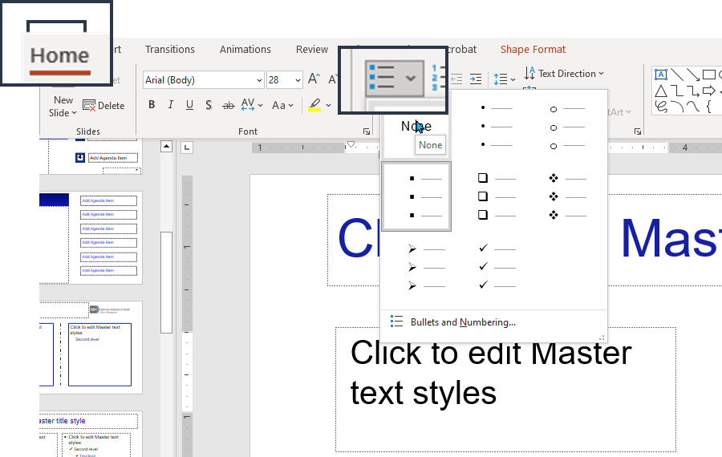

You format a placeholder in Slide Master view. Then you use the placeholder—add content to it—in Normal view.

|  |  |
| --- | --- |
| Optional - In the Font group, change the Font Size (maybe a smaller font).  Highlight the text in the placeholder to select it. Click on the down arrow next to the Font size. Select a smaller size.  Please consider the amount of information the placeholder can hold—a minimum 18pt for PowerPoint. |  |
| Optional – Highlight the text in the placeholder to select it. Click on the down arrow next to the Font color. Select another color. |  |
| Optional – Add a Border. Click on the Text Placeholder to select it. Click Shape Format. |  |
| Click the Shape Outline option. You can change the line weight color and add curvy (Sketched) or Dashes. |  |

#### Resize a Text Placeholder

There are a couple of ways to resize a Text placeholder. 1) you can click on the placeholder to select it, then use your mouse to resize it. 2) you can change the height and width of the shape.

|  |  |
| --- | --- |
| View > Slide Master > Select the placeholder to activate the Shape Format menu option. |  |
| Click Shape Format. On the far right of the ribbon is the Size group.  Change the dimensions of the Height and Width of the placeholder. |  |

#### Re-shape a Text Placeholder

|  |  |
| --- | --- |
| Click the Text Placeholder to select it. Click on the Shape Format menu option. |  |
| Click Edit Shape > Change Shape > Select a shape, for example, a rectangle with rounded corners. |  |
| You can also change the alignment of the text within the placeholder, add a shape effect such as a shadow, or enhance the line by adding thickness or dashes. |  |

### Align Placeholders

If you are unfamiliar with this concept, please take a moment to view a short video on how to align placeholders. [How to Align in PowerPoint](https://youtu.be/DdHbK2Pl-XI?si=Jo-gNB7BM-4LdnJ4) ( **8min 17sec**).

|  |  |
| --- | --- |
| In Slide Master view.  Click the first placeholder, then CTRL+Click subsequent placeholder(s). |  |
| Click the Shape Format menu option. In the Arrange group, select the down arrow under the Align icon. |  |
| Select the appropriate alignment. |  |
| For example, Align Left. |  |

### Copy a Placeholder

**Do Not Copy placeholders in Normal view.** Copy and paste placeholders in **Slide Master** view only. **In** Slide Master **view, right-click the placeholder and click** Copy. Paste **the placeholder into the appropriate layout.**

|  |  |
| --- | --- |
|  |  |

**Normal View** - If you need to copy a text placeholder, right-click on the thumbnail in Normal view, then click **Duplicate** Layout. This way, you keep the attributes of the text placeholder. If you copy and paste a text placeholder in Normal view, PowerPoint will convert it to an **inaccessible** Text Box.

### Picture Placeholders

Learn how to create cool, dynamic image layouts in PowerPoint. Take a moment to view the following recommended video tutorials.

* [How to Create a Modern PowerPoint Template Preview](https://youtu.be/mUdECnUow70?si=7gwWhpNmbc1zsTfb) (**5min 18sec**).
* [PowerPoint Tutorial](https://youtu.be/0p9idcFye0g?si=zqzHQpmOQCbW2rYk) | Presentation Design | Pictures - (**8min 26sec**).
* [Custom Shape Image Placeholder in PowerPoint](https://youtu.be/wu81qJsyqXU?si=JLfQElvxOfuIqYny) – (**2 min 34sec**).
* PowerPoint Tip: [Create Custom Image Placeholder Shapes](https://youtu.be/Wf0JnCIyQ6s?si=97XZTVqsAGNi0zpR) (video **8min** **12sec**).

#### Insert a Picture Placeholder

|  |  |
| --- | --- |
| View > Slide Master > Insert Placeholder > Picture. |  |
| Insert the Picture placeholder into the appropriate layout workspace.  Use the mouse to re-size it or click Shape Format and change the Height and Width. |  |

#### Picture Placeholder vs. Content Placeholder

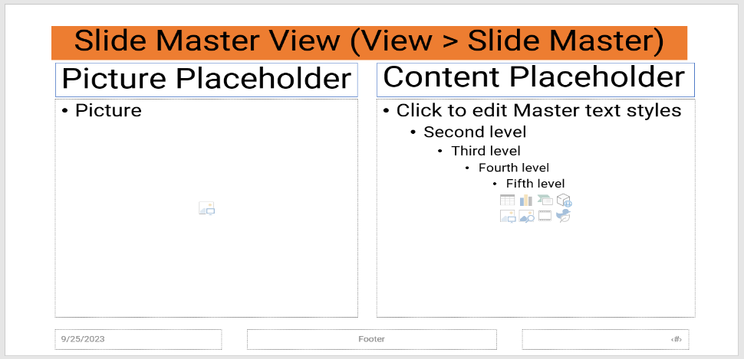

The **Picture** placeholder fills the placeholder space with the image.

For example, if the placeholder dimensions are 4 x 6, the picture will fill that space. It will crop the image if necessary. The Author can [**un-crop**](https://guides.lib.umich.edu/c.php?g=283149&p=1888300#:~:text=You%20can%20get%20the%20cropped,area%20is%20now%20gone%20permanently.) the image if needed.

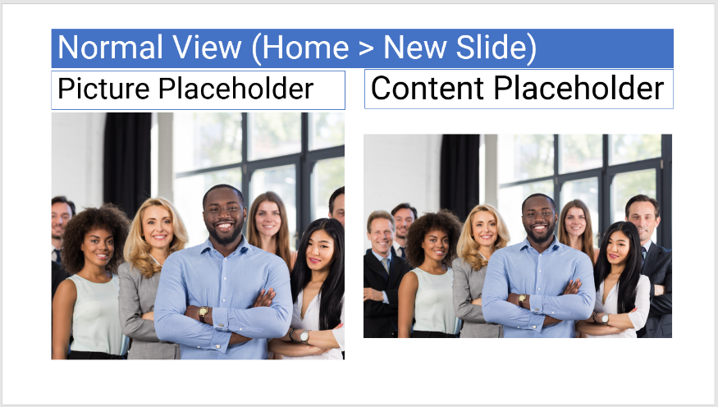

The **Content** placeholder will insert the entire picture; however, it may change the image’s dimensions.

#### Change the Shape of a Picture Placeholder

By default**,** the image placeholder will be a square**.** However**,** you can change the shape of the image placeholder on the PowerPoint layout.

Click thePicture Placeholder **(workspace).** This will activate the **Shape Format** menu option.

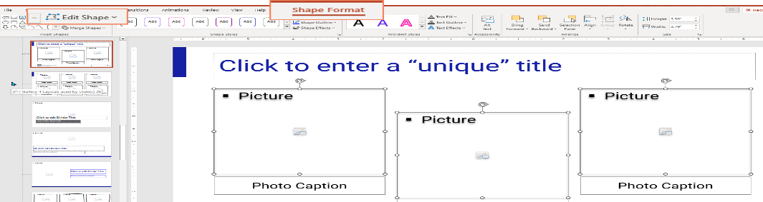

|  |  |
| --- | --- |
| Click Shape Format > click Edit Shape > Change Shape. |  |
| Select the appropriate shape from the options presented. | Example of the Basic Shapes in the Change Shape menu options. |
| Check your work.  Click the Slide Master tab and click Close Master View. |  |
| Click Home > New Slide > Select the appropriate Layout – insert an image to test the new design. |  |
| For Example 🡪 | A heart-shaped image of two polar bears sitting upright, smiling for the camera. |

#### Add a Shape Effect to a Picture Placeholder

You can enhance the image by adding a shadow or adding a border. You can do so with Shape Format menu options. There are many options to choose from.

|  |  |
| --- | --- |
| In Slide Master view. Click the appropriate Picture placeholder to select it, then click Shape Format. |  |
| Add a Shadow  Next, click Shape Effects > Shadow > Offset: Bottom.  Try a few options before you decide – such as - Preset, Shadow, Reflection, Glow, Soft Edges, Bevel, and 3-D rotation. |  |
| Add a Border  Click the image to select it. Click Shape Format > Select Shape Outline > You can change the border's color, width, size, and style (Sketched or Dashes). |  |
| For Example 🡪 |  |

### Insert a Chart Placeholder

The Chart placeholder will retain its height and width. The pre-set will help make it easier to keep consistency throughout your presentation. You can add a single chart placeholder or multiple.

|  |  |
| --- | --- |
| View > Slide Master > Insert Placeholder > Select Chart. |  |
| Insert the Chart placeholder into the appropriate layout workspace.  Use the mouse to re-size it or click Shape Format and change the Height and Width. |  |

**For Example:**

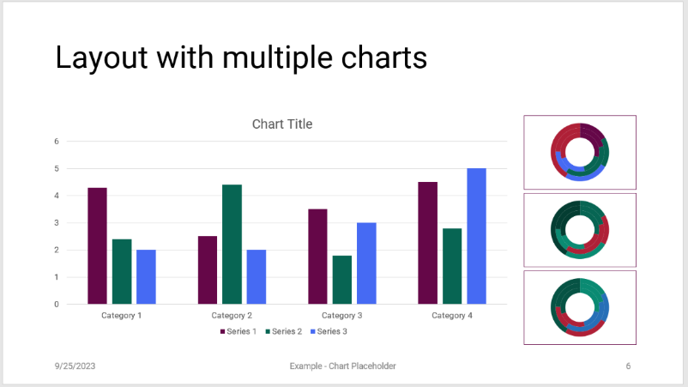

### Insert a SmartArt Placeholder

The SmartArt placeholder will retain its height and width. The pre-set will help make it easier to keep consistency throughout your presentation. You can add a single or multiple placeholders.

|  |  |
| --- | --- |
| View > Slide Master > Insert Placeholder > Select SmartArt. |  |
| Insert the SmartArt placeholder into the appropriate layout workspace.  Use the mouse to re-size it or click Shape Format and change the Height and Width. |  |

**For Example:**

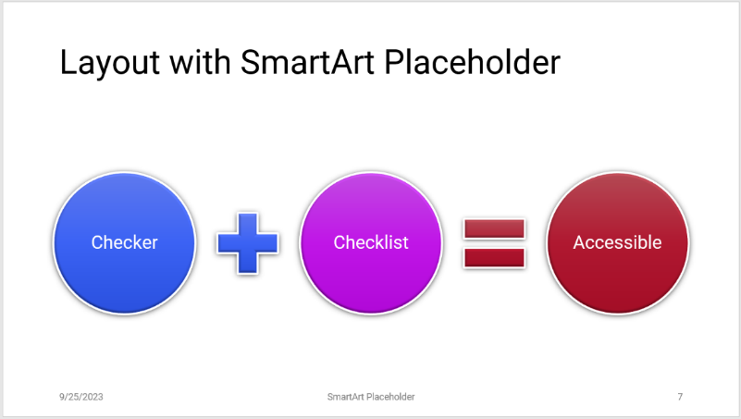

### Insert a Table Placeholder

Table placeholders **truncate** the placeholder according to the number of columns or rows entered in the **Insert Table** dialogue box.

**Best Practice** - Insert a **Text Placeholder** above or below the **Table Placeholder** for a caption or label. 508 requirement, small tables must display a caption, i.e., **Table 1: Quarterly Sales.**

See Create a Text Placeholder as a Label or Caption for more information.

|  |  |
| --- | --- |
| View > Slide Master > Insert Placeholder > Select Table. |  |
| Insert the Table placeholder into the appropriate layout workspace.  Click Shape Format and change the Height and Width. |  |

**For Example**

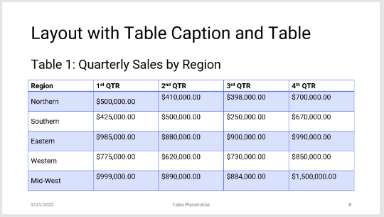

# Troubleshooting Placeholders

The **Template Designer** and the **Author** should be aware of the following issues when creating and using PowerPoint placeholders.

## Decrease File Size

Several factors can increase the file size of a PowerPoint presentation. For example, pictures, charts, media, and tables can increase the size of the presentation. Large presentations, in most cases, cannot be emailed. Some users may not be able to download large files.

Before the presentation is posted or distributed, follow the instructions below to decrease file size when the presentation contains pictures, tables, charts, or media.

### Picture Placeholders

Customized images can drastically increase the file size of the PowerPoint presentation. Be mindful of your target audience.

Large files should not be distributed via email. Agencies can limit the size of the information sent. Posting large files also presents a problem because some people may not have a fast internet connection.

In either event, it makes the file inaccessible.

This is a straightforward fix. **Best Practice:** Perform the following steps before the final save.

|  |  |
| --- | --- |
| Check the File Size, then decrease it by compressing the images within the presentation.  To check the File Size. Click **File** > **Info** > **Properties**. | **File > Info > Properties**  Screenshot of the File Size. |
| Click a single image within PowerPoint (Word, Excel, or Outlook) to select it.  Click **Picture** **Format** > **Compress** **Picture**. Uncheck ‘**Apply only to this picture**,’ and leave the checkmark next to **Delete** cropped areas of pictures.  Select **Web (150 ppi):** good for web pages and projectors; click **OK**.  **Save** (CTRL+S) your document. View the file size **File** > **Info** > **Properties**. | Screenshot of Compress Pictures |

If changes occur after the final save, repeat this process.

### Table Placeholders

Copying and pasting tables from other sources (i.e., Excel) into PowerPoint may bring hidden attributes that increase the file size.

The source file must be stored on OneDrive, a shared network (for internal distribution), SharePoint, or an external website.

**To reduce the file size:**

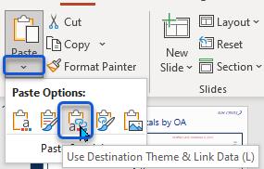In the source file (i.e., **Excel**), right-click the table and click **Copy**.

In **PowerPoint** – Click the **Table** placeholder to select it, then click **Paste Options** (beneath the Paste icon, click the down arrow), and click the **Use Destination Theme & Link Data (L)** icon.

So, the next time the source file is updated, so will the PowerPoint presentation.

### Chart Placeholders

Copying and pasting charts from other sources (i.e., Excel) into PowerPoint may bring hidden attributes that increase the file size.

The source file must be stored on OneDrive, a shared network (for internal distribution), SharePoint, or an external website.

**To reduce the file size:**

In the source file (i.e., **Excel**), right-click the chart and click **Copy**.

In **PowerPoint** – Click the **Chart** placeholder to select it, then click **Paste Options** (beneath the Paste icon, click the down arrow), and click the **Use Destination Theme & Link Data (L)** icon.

So, the next time the source file is updated, so will the PowerPoint presentation.

#### Paste Options

For more information, click the appropriate link below.

[PowerPoint](https://www.youtube.com/watch?v=iolpccOoNtU) – Paste Options –video (7 min 56 sec)

[Excel](https://support.microsoft.com/en-us/office/paste-options-8ea795b0-87cd-46af-9b59-ed4d8b1669ad) – Paste Options – thoroughly examine the many paste options in Microsoft Excel.

[Word](https://youtu.be/2t1ujvVisSE?si=tNhe4_QnBtC_K_lU) – Paste Options – video (1 min 18 sec)

### Media Placeholders

It is best practice to link the media instead of compressing.

**Link to video** – insert an image or text, right-click the image or text, click **Link**, and insert the URL.

**Online Videos** – **Insert** > **Media** > **Video** > **Online Video** > Enter the URL (address) > **Insert**.

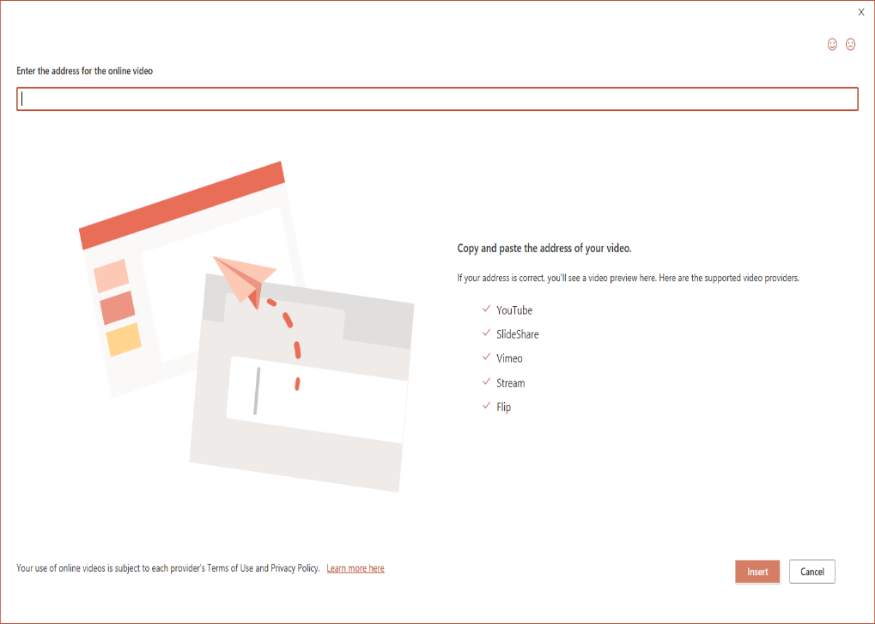

Supported video providers – YouTube, SlideShare, Vimeo, Stream, and Flip.

**To insert Online Media in PowerPoint, you must own the video.** If you are not the video owner, add a link to the media. This method triggers the Missing Audio or Video Sub-titles accessibility error. To correct this error, you must insert the captions. However, a process must be followed to achieve this because the Insert Captions option in PowerPoint is greyed out.

**Compress Media** – **File** > **Info** > **Compress Media** > Select the appropriate option.

Note: Some older video file formats may not compress or export correctly. Embedded subtitles and alternate audio tracks will be lost in the compression process.

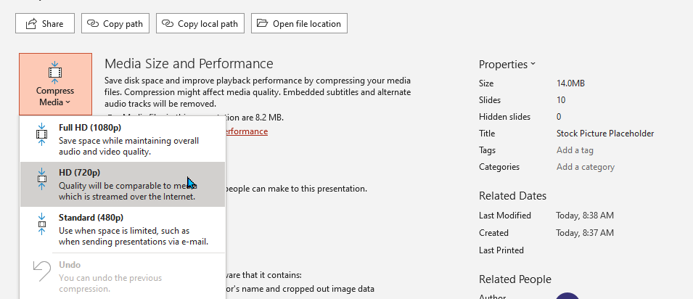

## Accessibility Checker Triggers

The Author may trigger the Check Reading Order error when the following conditions apply. At this point, it is the Author’s responsibility to correct the issue.

### Check Reading Order – Pictures

Once an image is inserted into the Picture placeholder, and you want to replace it, **do not delete** the image. Instead, click the image to select it, click Picture Format in the Adjust group, select Change Picture, and select one of the following choices.

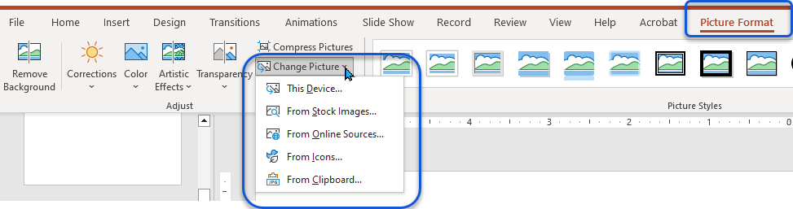

**This Device…** select an image from the Picture Library.

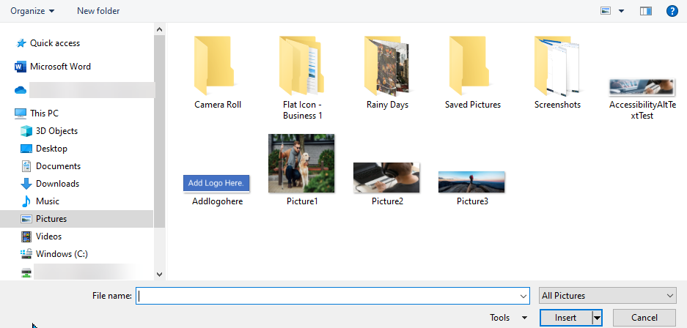

**From Stock Images**…select an image from online stock. It provides various options—images, icons, cut-out people, stickers, illustrations, and cartoon people. Click **Insert**.

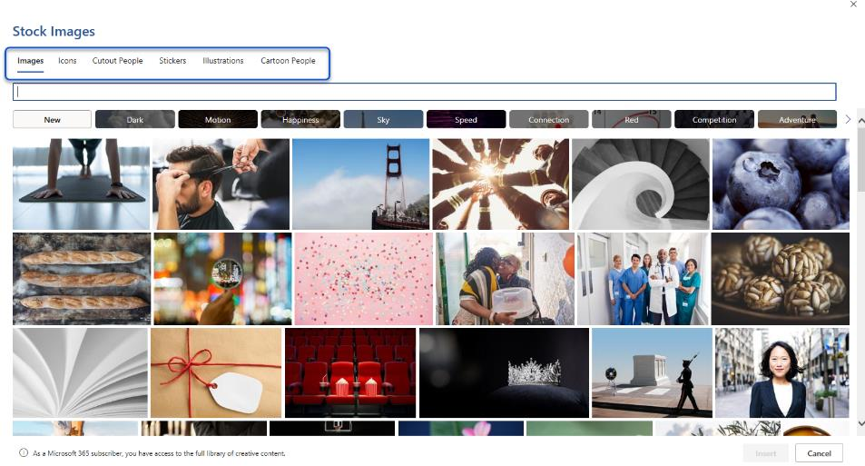

**From Online Sources: Select** or **Search** for the appropriate image. Click **Insert**.

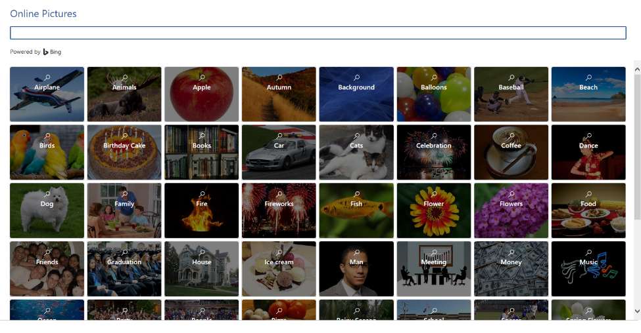

**From Icons – Select** or **Search** for the appropriate icon. Click **Insert**.

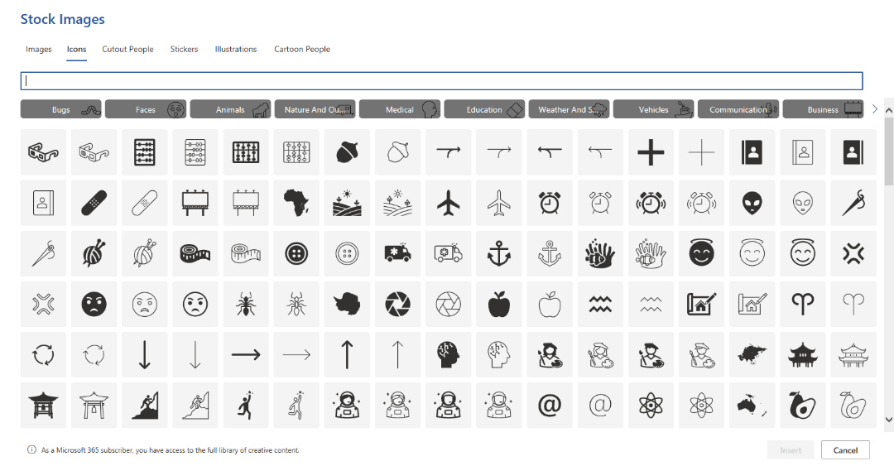

**From Clipboard**

Right-click an image, click **Copy**, then select the **Clipboard** option.

If you do not select one of the options listed above, you will trigger the Check Reading Order error when you run the Microsoft Accessibility Checker.

**To correct this error.**

Click **Review** > **Check** **Accessibility** > **Reading Order Pane**. Use the up/down arrows to readjust the reading order pane. It’s typically the Picture Placeholder that is out of place.

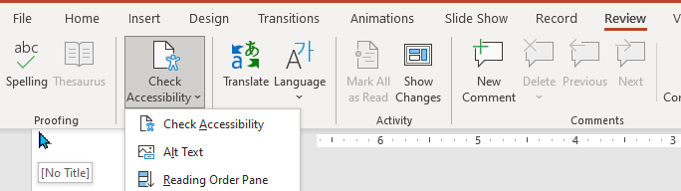

### Check Reading Order – Charts and Tables

The Paste Options / Paste Link will trigger the Check Reading Order when you copy and paste a Chart from Excel to PowerPoint. It is best practice to copy and **paste link** to a chart because you can update the source file, so the next time you open PowerPoint, the updated information is available. This method also reduces the file size of the presentation.

**To correct the Check Reading Order error.**

Click **Review** > **Check** **Accessibility** > **Reading Order Pane**. Use the up/down arrows to readjust the reading order pane. It’s typically the Chart Placeholder that is out of place.



### Missing Table Header

This error is triggered when you copy and paste a table into PowerPoint.

**To correct Missing Table Headers error.** Click **Review > Check Accessibility** > in the Accessibility Inspection Pane…

|  |  |
| --- | --- |
| (Option 1) | (Option 2) |

Click the error to expand the selection and click **Use First Row as Header**.

Option 2: Click on the **Table Design** tab in the **Table Styles Options** group and check the **Header Row** box.

## Miscellaneous Placeholder Issues

In a perfect world, you would create your presentation and send it on its way. Unfortunately, there are times when you may encounter an issue. Here are a few tips and tricks to help you navigate PowerPoint.

### Crop, Insert, Replace Picture Placeholders

When you insert a photo into a content placeholder, the placeholder changes to fit the photo.

If the photo is smaller than the placeholder, you get white space around it.

When you insert a photo into a picture placeholder, the picture adapts to the placeholder. The smallest size of the image fills the width/height of the placeholder, and the more extended size of the image is cropped.

To un-crop the image, click the image, click **Picture** **Format** > **Crop** > **Fill**.

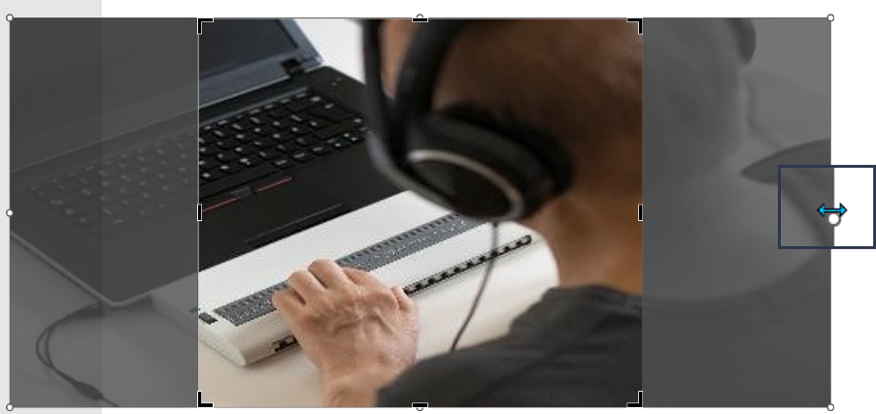

Use the bi-directional arrows to resize the image to fit the placeholder's width/height (left, right, top, or bottom).

**Note:** When you copy and paste an image into PowerPoint, you may bring over hidden attributes.

**Best Practice:** Click the **picture icon** in the Picture Placeholder or click the **Insert** > **Picture** menu option to insert the image.

**Replacing an Image:** Right-click the image and select the appropriate response. If you delete it and then replace the image, you will trigger the Check Reading Order.

**Corrective Action:** **Review** > **Check Accessibility** > **Check Reading Order** > **Verify Object Order**, move the picture to the appropriate place in the reading order of the layout.

### Can’t View Picture

This anomaly may occur in Slide Master or Normal view. This is a known Microsoft bug; the fix is below.

|  |  |
| --- | --- |
| **File** > **Save** **As** and save the file to a different location with a **different name**.  **Close** PowerPoint and reopen the file to see if the pictures display correctly.  **If this does not work, try restarting your computer – then reopen the file.** | Support for PICT images is being turned off in Office for Windows -  Microsoft Support |

### PowerPoint Opens in Slide Master View

This anomaly occurs when working in Slide Master view. **File > Options > Advanced > Display –** Select **Normal, thumbnail, notes, and slide** to return the presentation to the presentation (normal) view.

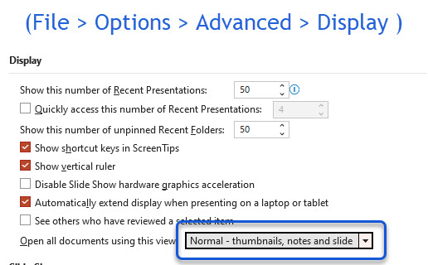

# How to Resolve the Microsoft Accessibility Checker Inspection Results

To access the Microsoft Accessibility Inspection Results – In any Microsoft Office 365 program, click **Review** > **Check Accessibility**.

The process remains the same for each accessibility issue, regardless of the program, in the Accessibility Inspection Results panel.

Accessibility Inspection Results panel showing the Missing alternative text error message. The recommended actions – Add a description or Mark as Decorative. Upon completion, the Accessibility Inspection Results panel should display “No accessibility issues found. People with disabilities should not have difficulty reading this document.”


* Click on the caret (>) next to the appropriate accessibility issue, for example, ‘Missing alternate text,’ to expand the selection.
* Click on the down arrow next to the first errored action.
* Select the appropriate Recommended Action.
* The Recommended Action will take you to the place in the document where the error was flagged.
* Corrected actions are removed from the Accessibility Inspection Results.
* Once the document meets the Microsoft Accessibility Checker requirements, the Accessibility Inspection Results will display…
* No accessibility issues found. People with disabilities should not have difficulty reading this document.

## Unable to Run the Microsoft Accessibility Checker

If you attempt to run the Accessibility Checker, you are met with an error message. Click the Convert button to convert the file to the most recent program.

You can also click **File** > **Save As** to save the document to the most recent version of the program.

You should now be able to run the Accessibility Checker.

## Check Reading Order

The corrective action for the Check Reading Order in PowerPoint versus Excel or Word differs vastly.

|  |  |
| --- | --- |
| Click the caret (>) next to Check Reading Order, click the down arrow next to the first action, and click Verify Object Order. |  |
| Use the up/down arrows in the Reading Order Pane to correct the reading order of the placeholders within the slide layout.  Repeat this process for each instance.  There are times when the reading order may seem illogical. For more info, see Reading Order Anomalies. | Example of the PowerPoint Reading Order pane showing actions ordered in illogical reading order. Instruction to correct the issue follows. Use the Up/Down arrows to move the information into a logical reading order. For example, 1) Title, 2) Content, 3) Image, and 4) Footer. Toggle between the   Accessibility Inspection Results &  Verify Object Order. (images of the Accessibility Checker and Verify Object Order icons.) |

Repeat this process for each instance.

The reading order of a slide layout depends upon the master slide and the placement of placeholders within the layout in both the master slide view and the ‘normal’ view.

See Reading Order Anomalies.

### Reading Order Anomalies

|  |  |
| --- | --- |
| Above - Objects placed Above the Title Placeholder are read after the Title Placeholder, and subsequent placeholders are read. |  |
| Right – Objects placed to the Right of the Title Placeholder are read in sequence, for example, Title (1), Text (2), and Picture (3). |  |
| Left – Objects placed to the Left of the Title Placeholder are read after the Title Placeholder, and subsequent placeholders are read. |  |
| Overlay – Objects that Overlay the Title Placeholder, the object is read first, then the Title, then subsequent placeholders. |  |

### Think Outside the Box!

There are times when the information cannot be contained in a placeholder.

* In this instance, **create a separate file for the original design**, then use third-party screen-capturing software to capture the information.
* **Save the original design in case you need to make changes.**
* Now, you are ready to place the newly created image in the **production presentation**.

|  |  |
| --- | --- |
| In PowerPoint, click Home > New Slide > select Title and Content Layout. |  |
| Note that the Title Placeholder is above the Content Placeholder.  Enter the appropriate title in the Title Placeholder.  Enter the appropriate alt text in the Content Placeholder. |  |
| Save the original design in a separate file.  Use [third-party software](https://www.techsmith.com/screen-capture.html) to flatten the image.  Copy and paste the single image into your presentation over the Title and Alt Text slide. |  |
| Mark the Image as Decorative. In the Inspection Results (Review>Check Accessibility), click on the error. Under Recommended Actions, select Mark as decorative. |  |

Repeat this process for each instance.

**Note:** The information behind the image will appear in Outline View – users of assistive technology rely on the information in **Outline View**.

**Illogical** – There are times when the reading order will pass inspection. However, it is not logical.

In this event, add a link to an accessible version of the information presented. Or use the Think Outside the Box method.

**Microsoft PowerPoint for Beginners** – ([video](https://www.youtube.com/watch?v=KqgyvGxISxk&t=283s)) - The key to an accessible document is using the software as intended.

Decorative items do not apply in the reading order; they are skipped by assistive technology.

Toggle between the Accessibility Checker and the Verify Reading Order icons to check your work. Corrected actions are removed from the Accessibility Inspection Results.

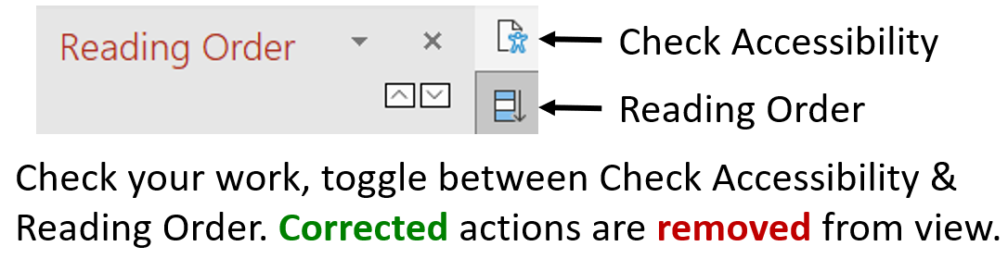

## Default Section Name

Click the caret (>) next to the error message.

Click on the down arrow next to the first action.

Click **Rename Section**. Enter a unique section name. Click **Rename**.

|  |  |
| --- | --- |
|  |  |

Repeat this process for each instance.

## Duplicate Section Name

Click the caret (>) next to the error message.

Click on the down arrow next to the first action.

Click **Rename Section**. Enter a unique section name. Click **Rename**.

|  |  |
| --- | --- |
|  |  |

Repeat this process for each instance.

## Duplicate Slide Title

Click the caret (>) next to the error message.

Click on the down arrow next to the first action.

Click **Edit Slide Title**. Enter a unique title in the Title Placeholder.

For example, Projected Sales (continued), Projected Sales I, or Projected Sales II.

|  |  |
| --- | --- |
|  |  |

Repeat this process for each instance.

Section and Slide Titles provide navigation for users of assistive technology; therefore, all slide titles and section names must be unique. Think of it as providing a road map for the user.

## Hard-to-Read Text Contrast

For this specific issue, the type of content, such as shapes, tables, fonts, and styles, may suggest a different option.

Click the caret (>) next to the error message. Click on the down arrow next to the first action.

Select the appropriate response.

|  |  |
| --- | --- |
|  | The color “Yellow” is not flagged as inaccessible in PowerPoint.  Yellow text on a white background is inaccessible. |

**Option 1 – Change the Font Color**

This option allows you to change the Font Color of the flagged action.

**Option 2 – Change the Shape Fill**

This option lets you change the fill color on various shapes, objects, and content.

### Color Contrast Tools

Please use one of the color contrast tools available to ensure your document meets the **Color Contrast Requirement** [**1.4.3**](https://www.w3.org/WAI/WCAG21/Understanding/contrast-minimum.html). The visual presentation of [text](https://www.w3.org/WAI/WCAG21/Understanding/contrast-minimum.html#dfn-text) and [images of text](https://www.w3.org/WAI/WCAG21/Understanding/contrast-minimum.html#dfn-image-of-text) has a [contrast ratio](https://www.w3.org/WAI/WCAG21/Understanding/contrast-minimum.html#dfn-contrast-ratio) of at least 4.5:1, except for the following:

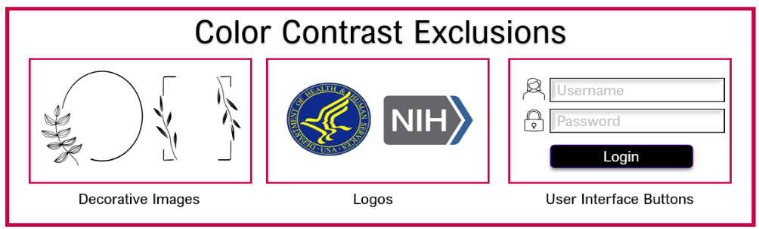

* Color Contrast Checker (online) – [WebAIM: Contrast Checker](https://webaim.org/resources/contrastchecker/)
* Colour Contrast Analyzer (download) - [Colour Contrast Analyzer - TPGi](https://www.tpgi.com/color-contrast-checker/)
* Resource: [A Total Guide to Accessible Colors](https://venngage.com/blog/accessible-colors/).

|  |  |
| --- | --- |
| The first set of traffic lights show red, yellow, and green.  The second set of traffic lights each light shows a person in a different pose along with a word. Red - Stop, Yellow - Wait, and Green - Go. | [Use of Color Requirement 1.4.1](https://www.w3.org/TR/UNDERSTANDING-WCAG20/visual-audio-contrast-without-color.html) - Color is not the only visual means of conveying information, indicating an action, prompting a response, or distinguishing a visual element. |

**OPTIONAL:** This is a tool to help you get started. You do not have to use it.

[**Accessible Color Combinations**](https://oalmsps.od.nih.gov/DDO/CDMP/508/Accessible%20Design%20Training/AccessibleColorCombinations.xlsx) [.xlsx].

A resource tool that provides the contrast ratio of several colors, hexadecimal codes, and whether the combination (text and background) passes the [WCAG](https://www.w3.org/WAI/WCAG21/Understanding/contrast-minimum.html) requirement.

## Missing Audio or Video Subtitles *

Click the caret (>) next to the error message. Use captions for audio and video.

Click on the down arrow next to the first action.

Click **Insert Captions**, and the file explorer menu box will open. Select the applicable [.[vtt](https://www.youtube.com/watch?v=NLfs-SUEerY)] file and click **OK**. See **Transcript File Formats**.

|  |  |
| --- | --- |
|  | Screenshot of File Explorer, showing the WebVTT file extension. |

Additional **Section 508 Standards** must be met when a video is inserted into a PowerPoint presentation.

For more information, see **Section 508.gov** – [Create Accessible Video, Audio, and Social Media](https://www.section508.gov/create/video-social/).

See also **HHS Checklist** – [PowerPoint](https://www.hhs.gov/sites/default/files/hhs-508-powerpoint-checklist.xlsx). Video – [Live captions and subtitles](https://support.microsoft.com/en-au/office/video-live-captions-subtitles-371bd124-855f-46a9-a923-5371c10f36c5). (1 min 8 sec)

|  |  |
| --- | --- |
| [3PlayMedia Beginner's Guide to Audio Descriptions](https://oalmsps.od.nih.gov/DDO/CDMP/508/Office%20365%20Digital%20Accessibility/Beginners-Guide-to-Audio-Description.pdf)  Click to download the white paper. | [The Beginner's Guide to Microsoft PowerPoint](https://www.youtube.com/embed/XF34-Wu6qWU?feature=oembed)  Example of Linked media. |

Best Practice – If possible, add a [link to the Media](https://support.microsoft.com/en-au/office/insert-a-video-from-youtube-or-another-site-8340ec69-4cee-4fe1-ab96-4849154bc6db) instead of inserting it into the presentation. **Not all formats are supported**. Videos from YouTube, Vimeo, SlideShare, and Microsoft Stream can be inserted.

Link Online Video: Find the video you want to insert and copy the URL in your browser. In PowerPoint - Click **Insert** > **Video** > **Online Video** > **Paste the URL** > select **Insert**.

Because the video is stored on a website rather than in your presentation, you must be connected to the internet for the video to play successfully.

### Transcript (.VTT / .SRT) File Formats

The referenced platforms automatically transcribe the audio of a meeting or webinar that you record. After the transcript is processed, it appears in a separate file in the list of recorded meetings.

| **Platform** | **File Type** | **Resources** |
| --- | --- | --- |
| Microsoft Teams | **.DOCX /.VTT** | <https://support.microsoft.com/en-us/office/view-live-transcription-in-a-teams-meeting-dc1a8f23-2e20-4684-885e-2152e06a4a8b> |
| Microsoft Stream | **.VTT** | <https://www.youtube.com/watch?v=RnUNiCb2kmw> |
| WebEx | **.VTT** | <https://help.webex.com/en-us/article/npoakae/Download-a-recording-transcript-for-Webex-meetings,-webinars,-and-events> |
| YouTube | **.SRT** | <https://youtu.be/AYNuOO8TFiY> |
| Zoom | **.VTT** | <https://support.zoom.us/hc/en-us/articles/115004794983-Audio-transcription-for-cloud-recordings> |

Before posting the transcript, ensure it is accurate and typographical error-free.

Once you upload the transcript for the video, you can satisfy the **Missing Object Description** error by stating, “Closed Captions included for this video (Add Title).”

## Missing Object Description*

Also known as Missing alternative text.

Click the caret (>) next to the error message. Click on the down arrow next to the first action.

Select the appropriate response.

|  |  |
| --- | --- |
|  | Screenshot of the POET Training Tool - How to Describe Images. |

**Option 1 – Add a Description**

Click the error to expand the selection, click **Add a Description**, and enter the appropriate alternate Text.

**Resource:** **POET Tool** – [**How to Write Alt Text for Objects**](https://poet.diagramcenter.org/how.html)

**Option 2 – Mark as Decorative**

Mark the object as decorative if it does not contain pertinent information to explain the content.

### Guidelines for Writing Alt Text

Alternative text (i.e., "alt-text") must always be informative and descriptive of the content in the image. It can have character and humor, but it must still be informative and descriptive. Alt text is not a place to add easter eggs or jokes for sighted users.

Wherever you use images, use alt-text to describe images for people who can't see them. This is useful for:

* People who are blind or have low vision; their screen reader will read aloud the image description instead of just saying "Image."
* People with network problems; when images fail to load, alt-text clarifies what they might otherwise miss.
* Course designers and instructors, thinking about succinct alt-text helps you think about why you're using the image in the first place.

The writer needs the following:

* Detailed knowledge of the subject matter.
* Good writing skills and an excellent command of the vocabulary associated with the subject.
* A review/edit process. Descriptions should be reviewed for accuracy and grammar by someone other than the original writer (and the technical staff).

Engage your content owners, especially your scientists and researchers, who may need to be better versed with Section 508.

* Sell them on their engagement – greater accessibility equals greater exposure.
* Remind them that Section 508 is not about lowering the quality of their content but making it available to a broader audience – academic credentials are still required.
* Get buy-in from the content owners.
* In addition, follow the general rules for applying alternate text – for example.
* Context - Survey the text surrounding an image to understand how it fits into the bigger picture.
* Use context to decide which basic concepts and terms have already been explained and avoid repetition of explanations.
* Use vocabulary and phrases appropriate for the reader.

**Concise** - More is NOT better – be succinct. Most images can be described in two or three sentences. For more complex information, provide an accessible alternative.

Don’t repeat information presented in the primary or adjacent texts. Instead, direct readers to existing descriptions (e.g., captions).

Include color only when it is significant (e.g., arbitrary colors assigned for elements of bar graphs and line charts need not be specified).

## Missing Slide Title

Each slide in the deck must have a unique title.

|  |  |
| --- | --- |
| Click the caret (>) next to the error message.  Click on the down arrow next to the first action.  Select the appropriate response. |  |
| Option 1 – Set as Slide Title  This option changes the Text Box to a Title Placeholder.  Do not use Text Boxes! Always select the appropriate placeholder.  Home > New Slide or Home > Layout. |  |
| Option 2 – Add Slide Title  This option allows you to add a Title Placeholder.  Option 2a – Add Slide Title  Home > Layout > then select the appropriate layout (Title only). |  |
| Option 3 – Add Hidden Slide Title  This option allows you to add a Title Placeholder above the slide window (hidden).  There are times when the real estate of the slide does not allow for a title. |  |
| Option 4 – Enter the Title Name in the Outline View.  Click View > Outline View and enter a unique title next to the appropriate slide number. |  |

Repeat this process for each instance.

## Missing Table Headers*

A table header row contains column headings, providing context and aiding table navigation. People who can’t see the table can have the column heading read aloud by screen readers.

|  |  |
| --- | --- |
| Option 1: Click the caret (>) next to the error message.  Click on the down arrow next to the first action.  Select Use First Row as Header. |  |
| Option 2: Click the Table Design tab in the Table Styles Options group to check the Header Row box. |  |

Repeat this process for each instance.

## Review Auto-Generated Description*

This feature automatically generates alt text for pictures. This is a great feature; however, the technology does not accurately capture the picture’s content. Verifying the alt text description and making the necessary adjustments would be best.

|  |  |
| --- | --- |
|  | Screenshot of the POET Training Tool - How to Describe Images. |

**Option 1 – Add a Description**

Click the error to expand the selection, click **Add a Description**, and enter the appropriate alternate Text.

**Resource:** **POET Tool** – [**How to Write Alt Text for Objects**](https://poet.diagramcenter.org/how.html)

**Option 2 – Mark as Decorative**

Mark the object as decorative if it does not contain pertinent information to explain the content.

### Turn Off Automatically Generated Alt Text

Click **File** > **Options** > **Accessibility** > **Uncheck** ‘Automatically generate alt text for me,’ and click **OK**.

## Use of Merged or Split Cells*

|  |  |  |
| --- | --- | --- |
|  |  |  |

Click the caret (>) next to the error message Table has merged or split cells.

Click the first action. This will take you to the slide that contains the table (for example, Slide 1).

Next, highlight the merged cells within the table. On the **Main** **Menu**, click the **Layout** tab and **Split** **Cells**.

When the split cells dialogue box appears, select the appropriate number of columns/rows to unmerge the cells. Click **OK**.

## Microsoft Accessibility Checker Limitations

The Microsoft Accessibility Checker catches many accessibility issues but does not capture them all. For example, the Microsoft Accessibility Checker cannot detect the following. Please refer to Standard HHS Checklist Requirements (below) to learn how to apply the appropriate corrective action.

* Document Properties, Filenames, Fonts, Language Preferences, Media (Audio / Video), and Paragraphs & Spacing.

# Standard HHS Checklist Requirements

This list is not all-inclusive. Please download the HHS [Accessibility Conformance Checklist](https://www.hhs.gov/web/section-508/accessibility-checklists/index.html) for Microsoft PowerPoint. Not all checklist requirements apply to every document. Here are some requirements that must be met.

[Each document has its own unique set of characteristics. 
 Not all 508 requirements apply to every document.
](https://www.hhs.gov/web/section-508/accessibility-checklists/index.html)

## Document Language

**[HHS ID 10A]** - Review > Language > Language Preferences displays the appropriate language for the presentation.

[**HHS ID 10B]** - The language of slide content in a different language is identified through Review > Language > Set Proofing Language.

Microsoft PowerPoint Language setting defaults to **English**. If the presentation is in a language other than English, follow the steps below.

Click **Review** > **Language** > **Language Preferences** > **Add a Language** > click **OK**.

Click **OK** on the message – Please restart Office, so your language changes can occur.

**If the presentation is part English and another language, set the Proofing Language.**

The Reveal Formatting pane (**Shift + F1**) > **Font**> **Language**displays the appropriate language for the document.

## Document Properties

[**HHS ID 9A**] – The presentation has a meaningful title indicating its purpose under **File** > **Info** > **Properties** > **Title**.

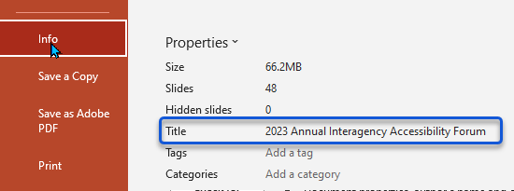

## Filename Conventions

A file naming convention is a framework for naming your files in a way that describes what they contain and how they relate to other files.

File naming conventions help you stay organized and quickly identify your files. A shared or collaborative group file-sharing setting will help others more easily navigate your work. Creating a naming convention will prevent a backlog of unorganized content and misplaced or lost data!

Technology is constantly changing. More and more people are being introduced to Power BI, SharePoint Online, and Yammer, now a part of Viva Insight, all requiring a descriptive filename. One that can be used across multiple platforms. Which means you must develop a naming convention for files and folders. As technology increases and the more products we use, correctly naming the document benefits everyone.

Per [ASPA/DCD General Office Documents](https://www.hhs.gov/web/section-508/making-files-accessible/checklist/aspa-dcd-general-office-document-file-508-checklist/index.html) –

* + Document file name should not contain any spaces or special characters.
  + Document file name must be concise, generally limited to 20-30 characters, and should clarify the file’s contents.
  + Spaces are poor visual delimiters, and some search tools do not work with spaces. The hyphen (-) is a common word delimiter.
  + Alternatively, capitalizing the words within an element is an efficient method of differentiating words.

## Filename Examples

**Example 1** – File names must not contain spaces or special characters – dashes are okay to use.

* SalesOfficeProcedures-508.docx

**Example 2** – Year-Month-Day [YYYY-MM-DD, YYYY-MM] – This naming convention will maintain chronological order.

* 2023-07-31-Agenda-508.docx

**Example 3** – Create versioning for frequently updated documents. Include a leading zero for numbers 0-9. This will maintain the numeric order in the file directory.

* OfficeProcedures-v01-508.docx

**Example 4** – Add 508 at the end of the filename to indicate that the document passed the Microsoft Accessibility Checker Inspection Results and complies with the HHS Checklist requirements.

* OfficeProcedures508.docx

### Resources – Filename Conventions

ASPA/DCD [General Office Document File 508 Checklist](https://www.hhs.gov/web/section-508/making-files-accessible/checklist/aspa-dcd-general-office-document-file-508-checklist/index.html)

Purdue University – [File Naming Conventions](https://guides.lib.purdue.edu/c.php?g=353013&p=2378293)

York University – Tip Sheet 6 – [Folders](https://ipo.info.yorku.ca/tool-and-tips/tip-sheet-6-naming-conventions-for-electronic-files-and-folders/)

Microsoft Video – [Create Accessible File Names](https://support.microsoft.com/en-us/office/video-create-accessible-file-names-4e73d73a-aedc-47af-88e4-8f2375a69fad)

## Flashing or Flickering Text

**Photosensitive seizures can be provoked by web or computer content flashing, including mouse-overs that cause large areas of the screen to flash on and off repeatedly.**

**Hazardous, seizure-inducing content has been inadvertently broadcast on television, causing mass seizures in children. As web content becomes more dynamic and media-rich, it is essential to prevent similar problems.**

**[HHS ID 8A] -**  No page content flashes more than three (3) times per second unless that flashing content is sufficiently small, and the flashes are of low contrast and do not contain too much red.

* Flashing or Flickering text or objects can cause seizures for individuals with photosensitive epilepsy.
* If you must use content that flashes, test your content using the Photosensitive Epilepsy Analysis Tool (PEAT)-[https://trace.umd.edu/peat/​​](https://trace.umd.edu/peat/).

**[HHS ID 7B] -** Moving, Blinking, Scrolling Text.

**Five (5) Seconds or Less**

* Moving, blinking, or scrolling text can draw attention to the slide if it lasts less than five (5) seconds.

**More than Five (5) Seconds**

* The user must be able to pause, stop, or hide the moving, scrolling, or blinking text (i.e., multimedia).

## **Hyperlinks**

When meaningful text is used for hyperlinks, screen readers can quickly scan the document and produce a helpful list of all available links.

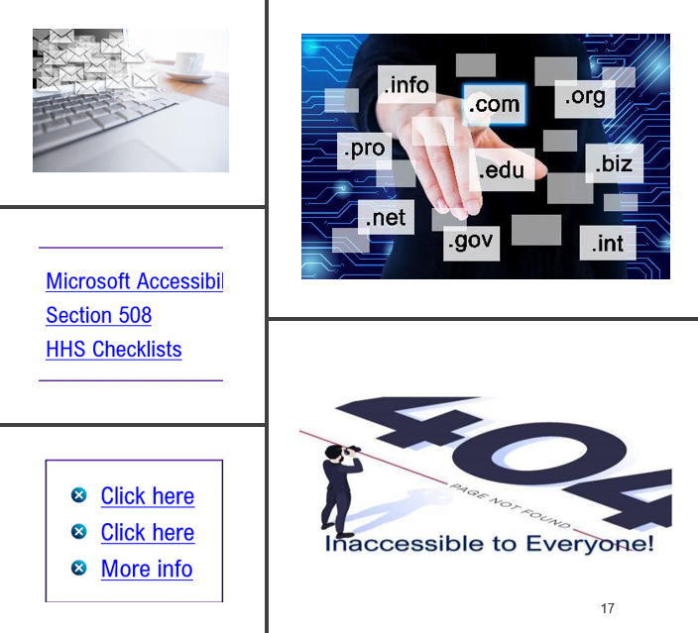

But this is only helpful if the list is meaningful.

For example:

* Click here for Microsoft Office’s Accessibility page.
* Click here to read section 508 of the Rehabilitation Act or
* Visit our website for more info.

This would produce the following list:

* Click here.
* Click here.
* More info.

This list needs to be more helpful and can be frustrating for the user. A better list would be generated using meaningful link text content. For example: Visit Microsoft Office’s Accessibility page and read Section 508 of the Rehabilitation Act for more information.

Ensure all links reach their target destination because a 404-error message makes the information inaccessible to everyone.



### Best Practices – Hyperlinks

If the hyperlink downloads a file, include the file type and size. For Example: [Document Title vs. Filename (PDF, 1465KB)](https://oalmsps.od.nih.gov/DDO/CDMP/508/508%20Quick%20Tips/HHS-DocFilenameTitle-r2.pdf).

Suppose the document opens in a new browser tab or opens to a new site. Be sure to include that information. For example, [HHS Accessibility Compliance Checklists (External)](https://www.hhs.gov/web/section-508/accessibility-checklists/index.html)

Write the full email address as link text rather than embedding it in the Text.

**Good:** Email the NIH Section 508 Help Team at: [Section508Help1@mail.nih.gov](mailto:Section508Help1@mail.nih.gov)

**Bad:** Email the [NIH Section 508 Help Team](mailto:Section508Help1@mail.nih.gov).

Place long URLs in an Appendix.

Hyperlinks must be distinguishable because many people can’t perceive color. Links should be underlined or different in some other way so there is no doubt whether the text is hyperlinked or static.

Always test links. A **404-error** message means the information is **inaccessible** to **everyone**!

## Print Grayscale

Apply to Microsoft PowerPoint Only - **View** > **Grayscale**. Scroll through the presentation. Persons who are color-blind may not be able to see some of the color combinations in your presentation. Grayscale offers a clear view of how those colors or lack of color appear in grayscale.

|  |  |
| --- | --- |
|  |  |

To exit **Grayscale**, click **Back to Color View**.

## Restricted Documents

**Do not restrict security settings in documents!**  
Information Rights Management (IRM) protection may prevent devices like screen readers from accessing the document.  
If you must use document restrictions, turn off the restrictions during Accessibility testing.

* Ask if reasonable accommodations are needed to use the document.
* Provide the user with the password to access the document.

## Transitions & Animations

PowerPoint has an option to have a slide transition after a specific time.

The default for this option is checked “On Mouse Click.”

Do Not change this setting.

**Video Title:** Accessible PowerPoint Presentations: Chapter Four: Transitions, Animation & Accessibility Testing.

[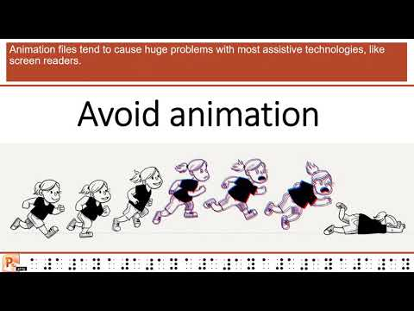](https://www.youtube.com/embed/zDHJrbfO164?feature=oembed)

View the short video – 4 minutes, 26 seconds.

# 508 Resources

## Test Accessibility – Narrator Screen Reader

Did you know that Windows has built-in functionality that will allow you to hear what users of assistive technology will hear when using a screen reader?

The [**Narrator**](https://support.microsoft.com/en-us/windows/complete-guide-to-narrator-e4397a0d-ef4f-b386-d8ae-c172f109bdb1) is a built-in function of **Windows**.

* Press the **CTRL**, **Windows** **logo**, and **Enter** keys on your keyboard to start the screen reader.
* Press **F6** until the focus, the blue rectangle, is on the content area. Or you can use your mouse to highlight the area you want to read.
* Press the **Tab** key to navigate the document, slide, or webpage content and fix the navigation order if needed.
* To move the focus away from the content, press **Esc** or **F6**.
* **Exit** the screen reader by pressing the **CTRL**, **Windows logo**, and **Enter** keys.

## Microsoft Accessible Templates

Templates that help you make your content accessible to everyone are now available on [create.microsoft.com](https://create.microsoft.com/).

You can find them by searching for "accessible templates" or using our query: [Accessible Office templates](https://aka.ms/AA6ijma).

Alternatively, you can get to them straight from your Office application. Go to **File** > **New** and type "accessible templates" in the Search for online templates box.

Start with a Microsoft template built for accessibility.

## Download Accessible Templates–

* Microsoft [PowerPoint](https://create.microsoft.com/en-us/powerpoint-templates) Templates
  + There are limitations with the PowerPoint Templates. Some contain only the slide layouts presented; sometimes, you will not have a Title and Content layout.
* Microsoft [Word](https://create.microsoft.com/en-us/word-templates) Templates
* Microsoft [Excel](https://create.microsoft.com/en-us/excel-templates) Template

Source: Microsoft.com – [Create designs that inspire](https://create.microsoft.com/en-us/excel-templates).

## Free Online Microsoft Courses

* The key to ensuring accessibility is using the software as intended.
  + Microsoft [PowerPoint](https://www.youtube.com/watch?v=KqgyvGxISxk&t=283s) for Beginners – Complete Course video. (52min 03sec).
  + Microsoft [Excel](https://youtu.be/wbJcJCkBcMg?si=Zgc9tUfEi549X-sV) for Beginners – Complete Course video. (54min 54sec).
  + Microsoft [Word](https://youtu.be/2MCmnr2L50o?si=5jUBPieuzR-4u_YM) for Beginners – Complete Course video. (43min 16sec).
  + Beginner’s Guide to Microsoft [Outlook](https://youtu.be/WfSCfBntqPU?si=mfnb1GSMr0EtteoJ) video. (12min 49sec).

## Accessibility Tools

* **Alternate Text** - To learn how to describe non-textual content (i.e., images, charts, etc.), check out the POET Training Tool - <https://poet.diagramcenter.org/how.html>.
* **Color Contrast** – The Colour Contrast Analyser – CCA (<https://www.tpgi.com/color-contrast-checker/>) is a **free** downloadable color contrast checker to determine the color contrast ratio.
* **HHS Checklist** - Apply the required **HHS Accessibility Conformance Checklist** requirements to the applicable document - <https://webaim.org/resources/contrastchecker/>
* **Snagit - Flatten Images** – Content with multiple lines and connectors; use third-party software such as **Snagit** (<https://www.techsmith.com/screen-capture.html>) to flatten the image. Apply the alternative text to the single image.

## 508 Resources - Laws, Guidance, Standards, and Training

**Laws, Guidance, Standards, and Training**

* Apply the required **HHS** [**Accessibility Conformance Checklist**](https://www.hhs.gov/web/section-508/accessibility-checklists/index.html) requirements to the document.
* [**Executive Order 14035**](https://www.federalregister.gov/documents/2021/06/30/2021-14127/diversity-equity-inclusion-and-accessibility-in-the-federal-workforce)– Diversity, Equity, Inclusion, and Accessibility in the Federal Workforce.
* **Section 508.gov** offers policies, laws, guidance, and tutorials for creating accessible content. [Home |](https://www.section508.gov/) Section 508. gov.
* The Web Accessibility Initiative (**WAI**) site [Making Audio Video Media Accessible](https://www.w3.org/WAI/media/av/transcribing/) walks users through everything from planning audio and video to creating an accessible media player.
* The Web Content Accessibility Guidelines ([**WCAG**](https://www.w3.org/WAI/standards-guidelines/wcag/)) provides international standards to explain how to make web content more accessible to people with disabilities.